**Ramniranjan Jhunjhunwala College of Arts, Science and Commerce**

**Department of Data Science and Artificial Intelligence**

**CERTIFICATE**

**This is to certify that Mr. Vishal Rajesh Dubey of Msc. Data Science and Artificial Intelligence Roll No 745 has successfully completed the practical of Paper – II (Semester-III) MACHINE LEARNING - II during the Academic Year 2023-2024.**

**Date :**

**(Prof. Mujtaba Shaikh)  
 Prof-In-Charge External Examiner**

|  |
| --- |
| **INDEX** |

|  |  |  |  |
| --- | --- | --- | --- |
| Practical No. | Practical Name | Date | Remark |
|  | **Unit I** | | |
| 1 | Implementation of any 4  types of Cross-Validation techniques. | 21-06-2023 | Completed |
|  | **Unit II** | | |
| 2.1 | Implementation of L2 Regularization | 26-06-2023 | Completed |
| 2.2 | Demonstrate how co-efficient gets affected by increasing values of the lambda(Alpha) | 27-06-2023 | Completed |
| 2.3 | In Ridge Regression prove that 'The more higher co-efficient are affected more' | 27-06-2023 | Completed |
| 2.4 | Implementation of LASSO Regression | 03-07-2023 | Completed |
|  | **Unit III** | | |
| 3.1 | Implementation of Voting Ensemble Learning | 11-07-2023 | Completed |
| 3.2 | Implementation of Bagging Technique | 14-07-2023 | Completed |
| 3.3 | Implementation of Gradient Boosting Algorithm | 21-07-2023 | Completed |
| 3.4 | Implementation of Stacking | 28-07-2023 | Completed |
| 3.5 | Implementation of K-means Clustering | 04-08-2023 | Completed |
| 3.6 | Implementation of Agglomerative Clustering | 08-08-2023 | Completed |
| 3.7 | Implementation of Density Based Clustering | 18-08-2023 | Completed |
|  | **Unit IV** | | |
| 4.1 | Perform Market Basket Analysis using apriori algorithm. | 25-08-2023 | Completed |

**Unit I**

**Practical 1.1**

**Aim : Implementation of any 4 types of Cross-Validation techniques.**

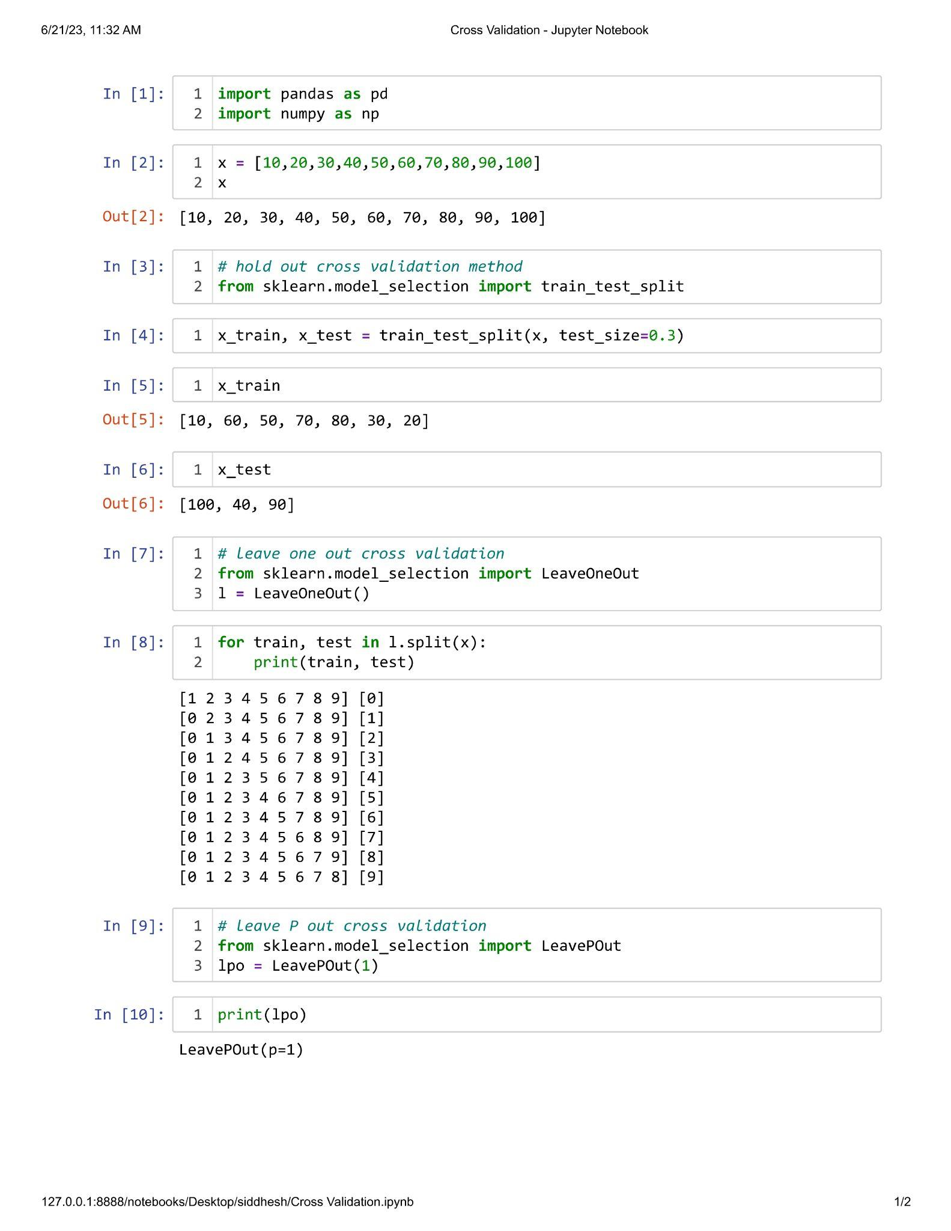

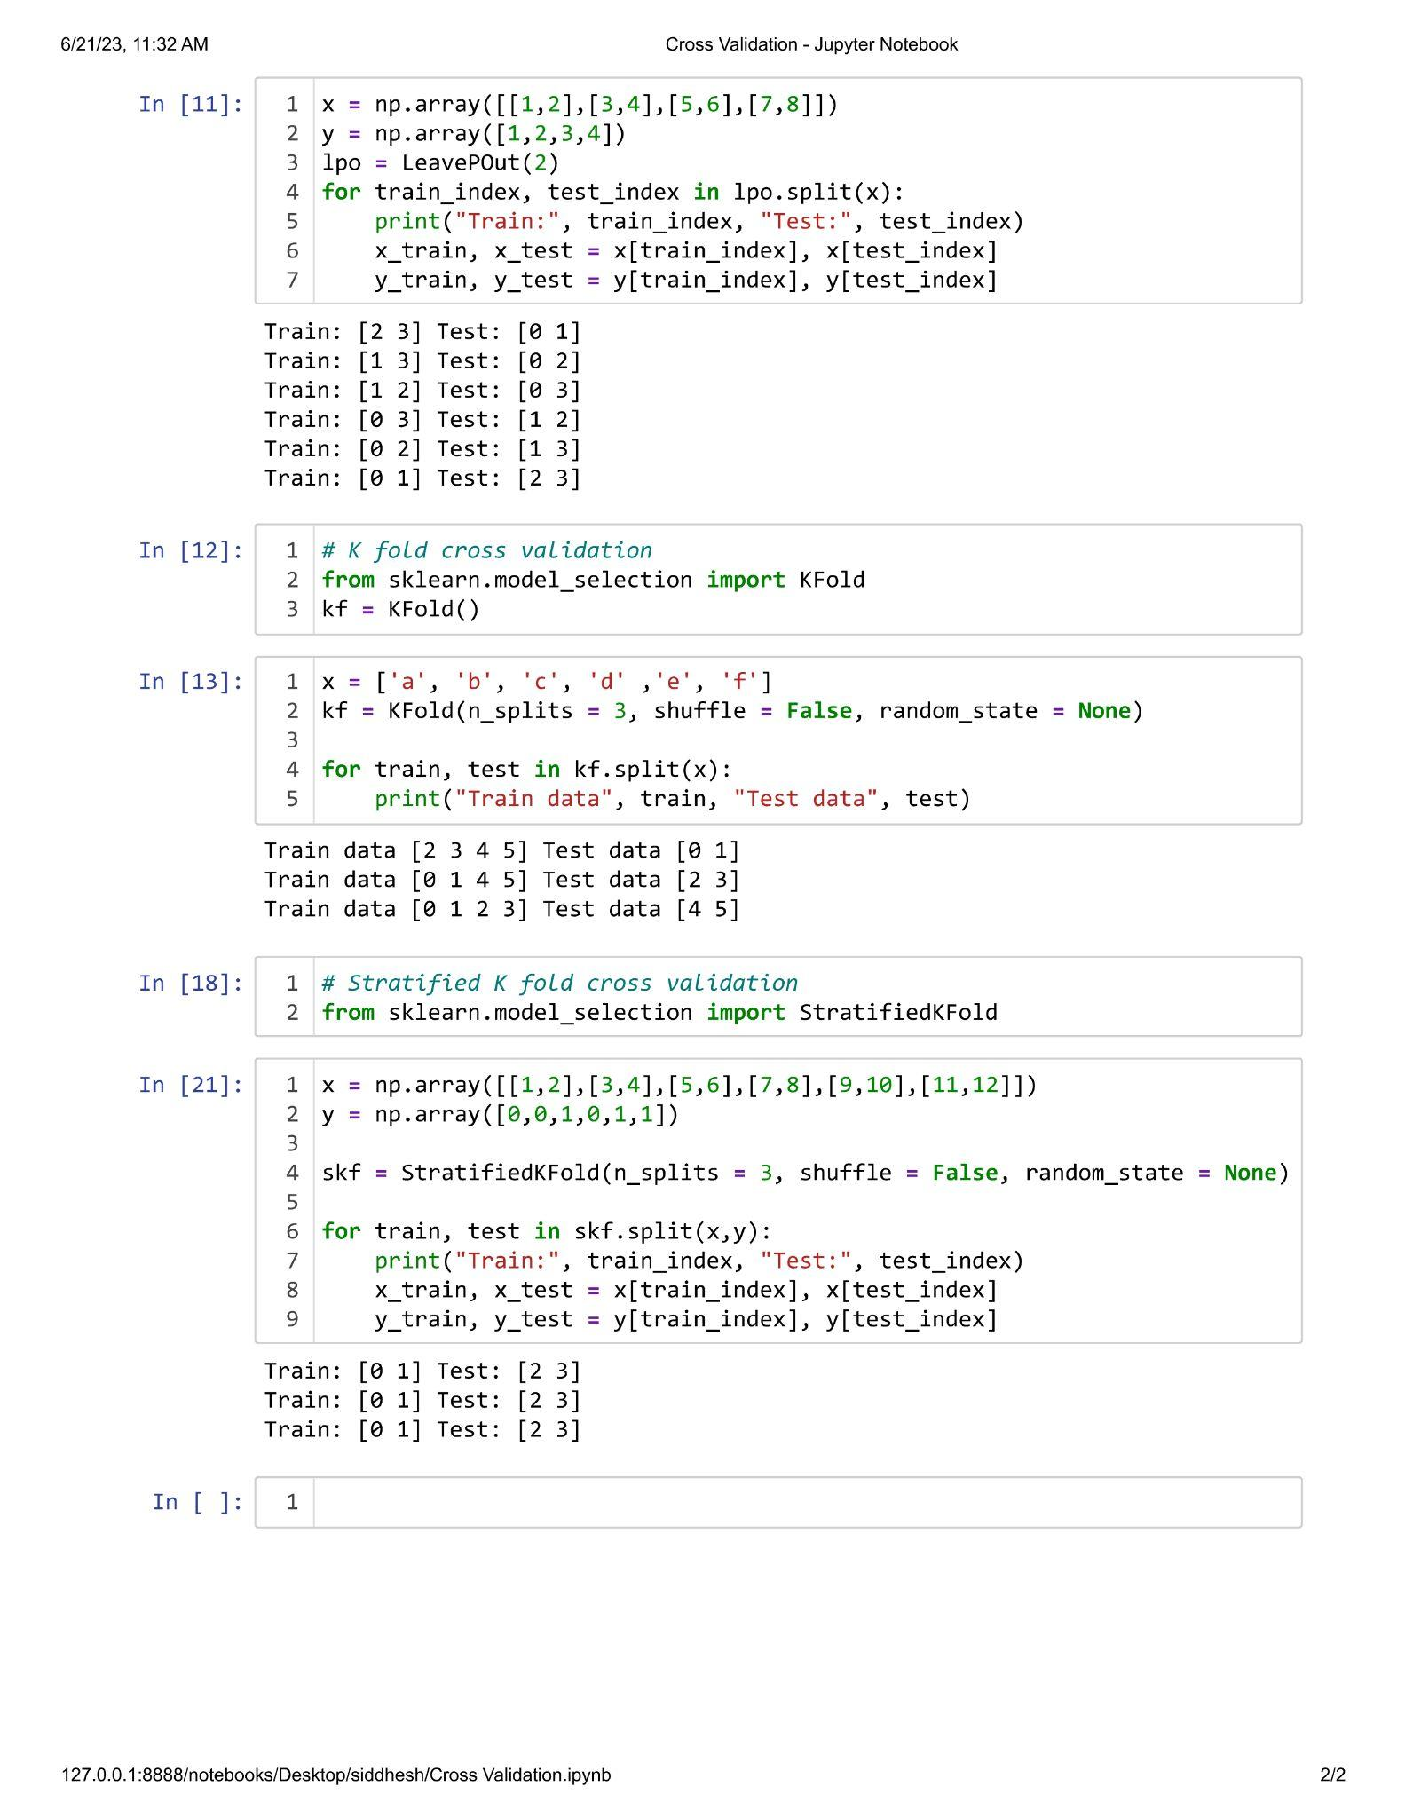

**Unit II**

**Practical 2.1**

**Aim : Implementation of L2 Regularization.**

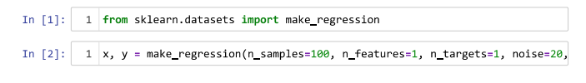



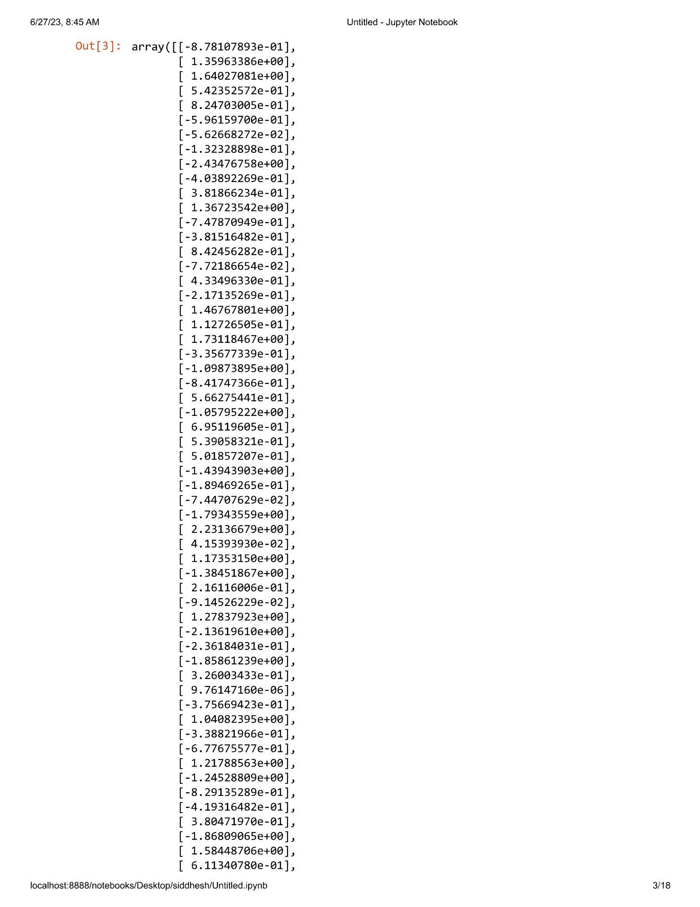

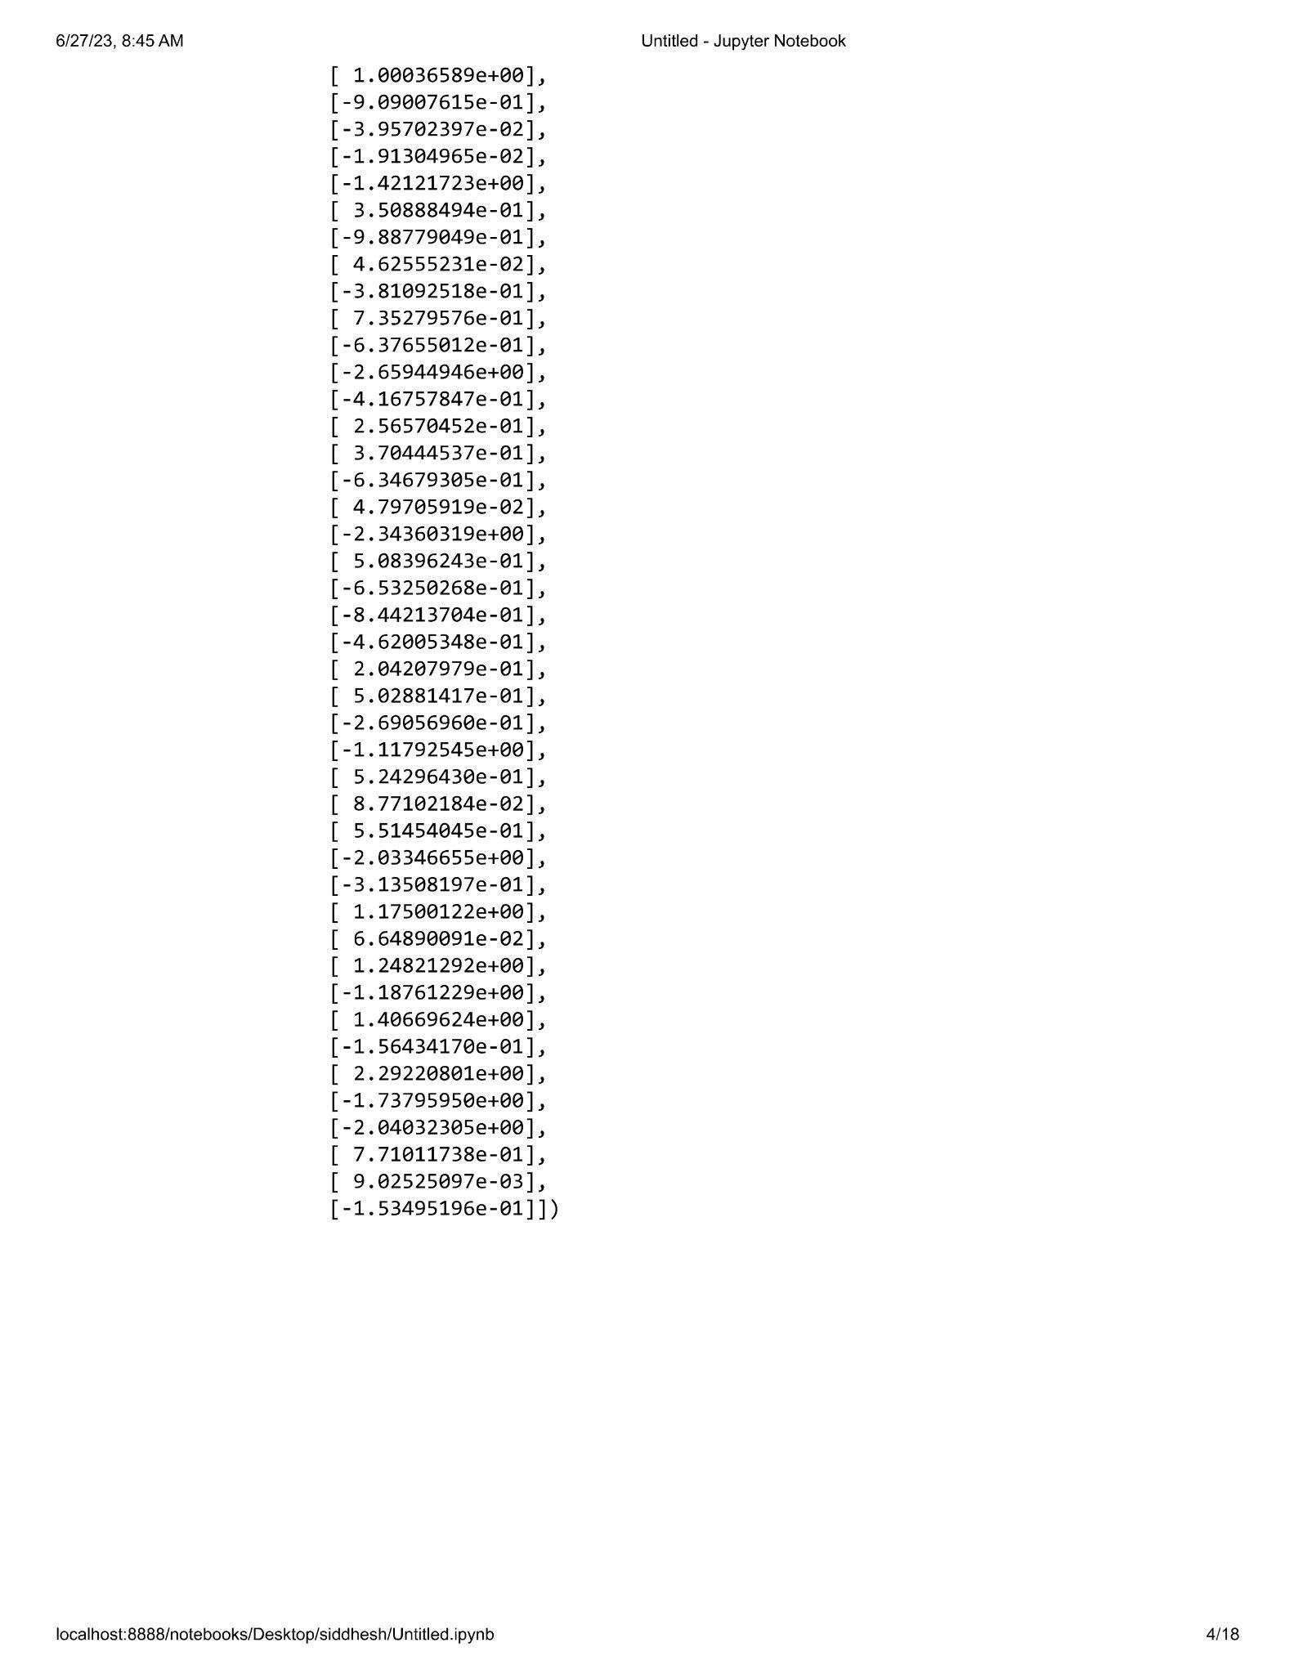

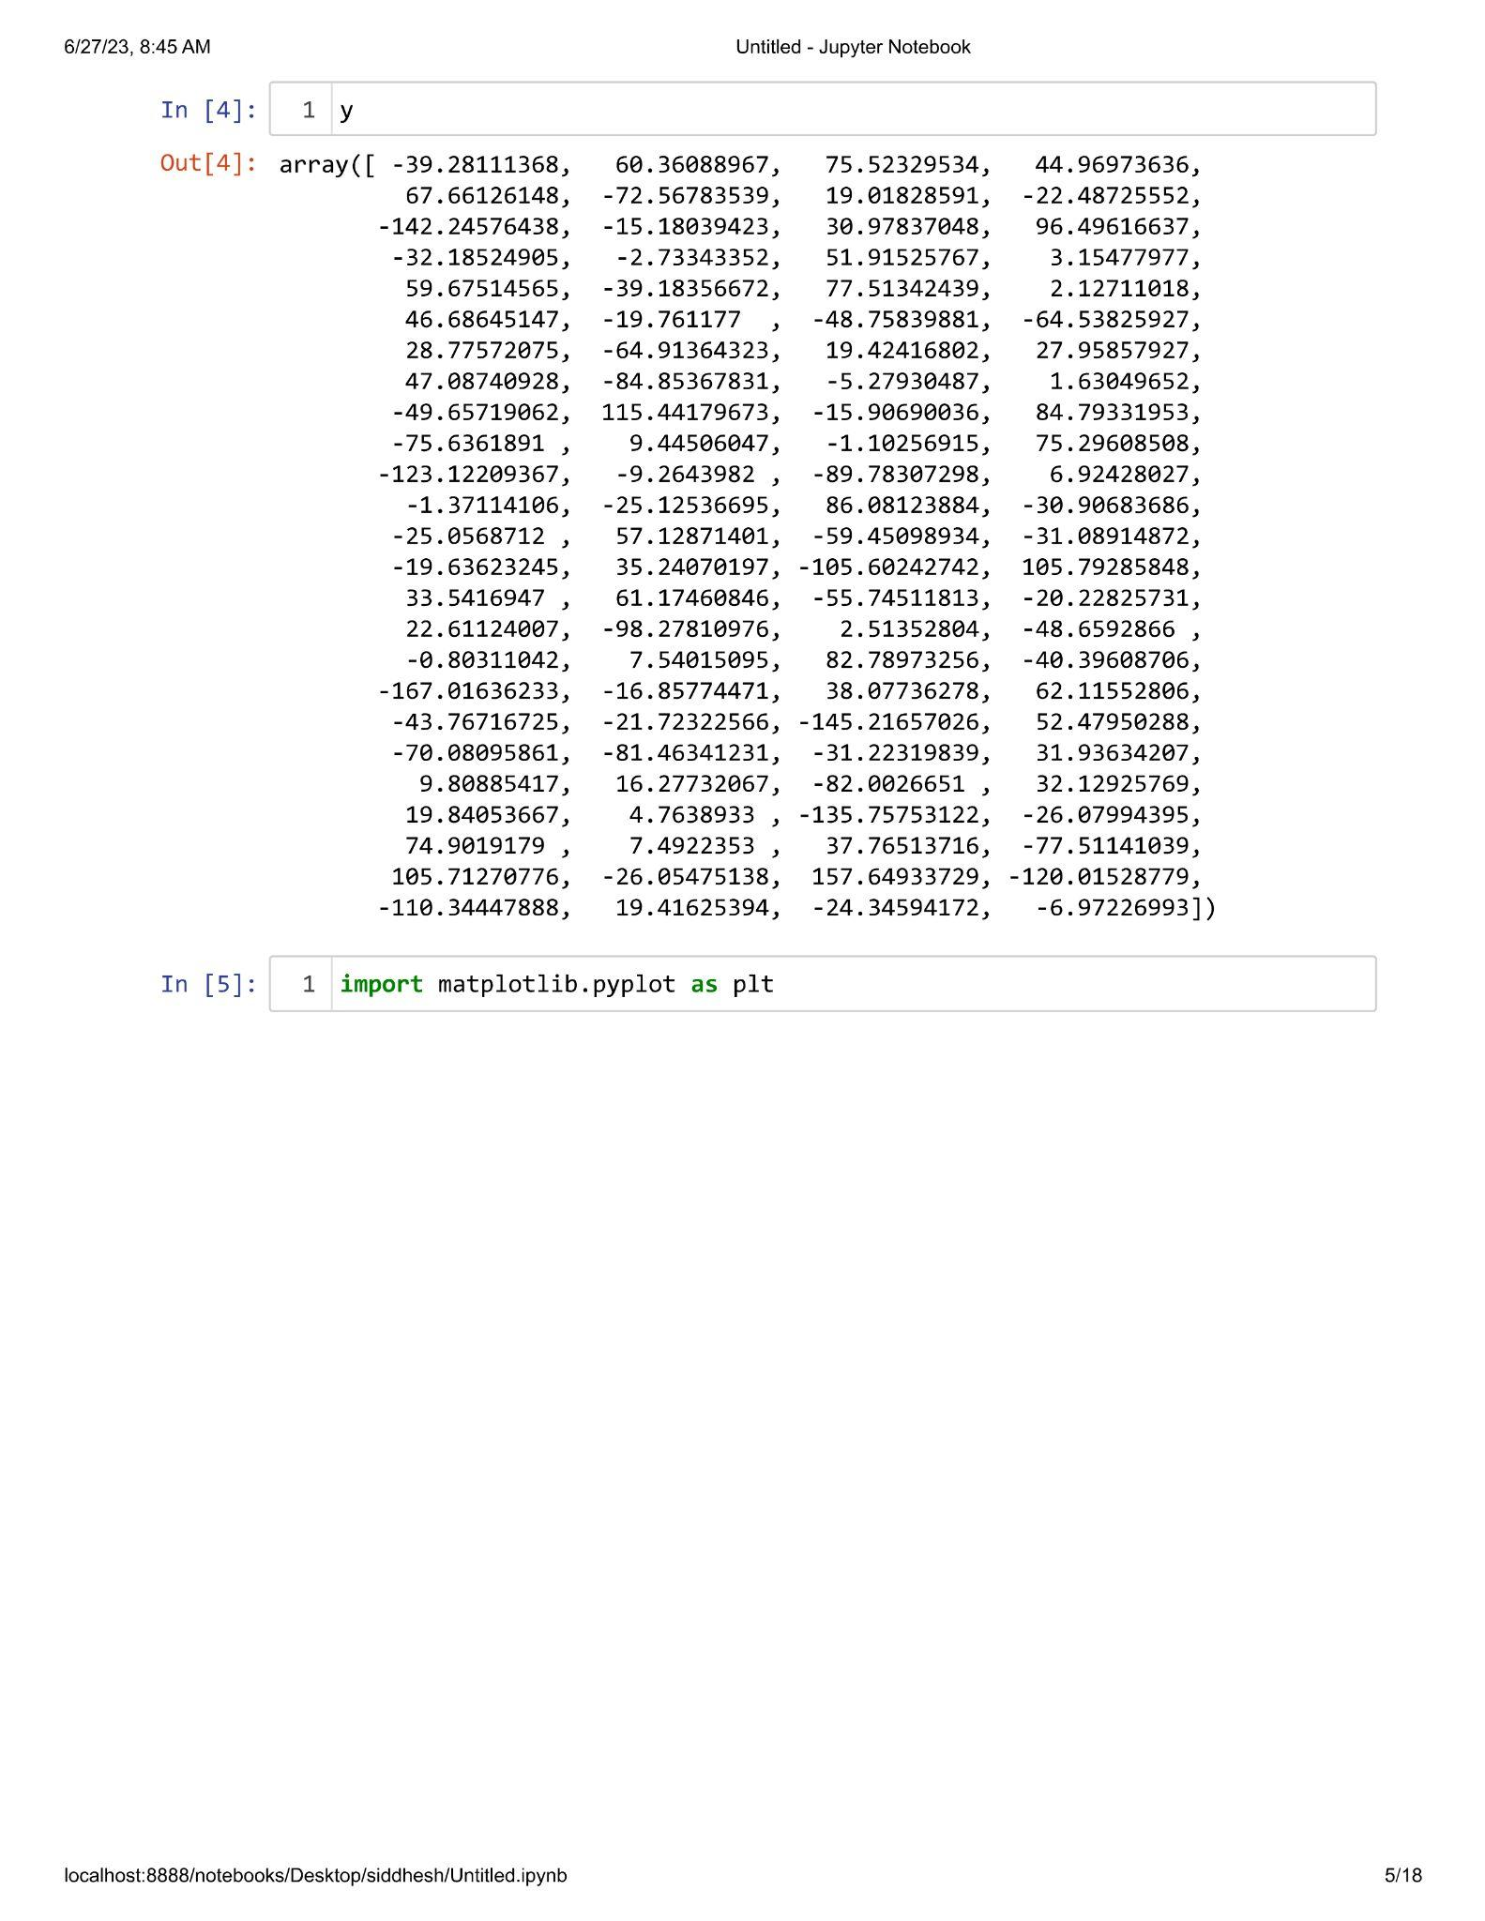

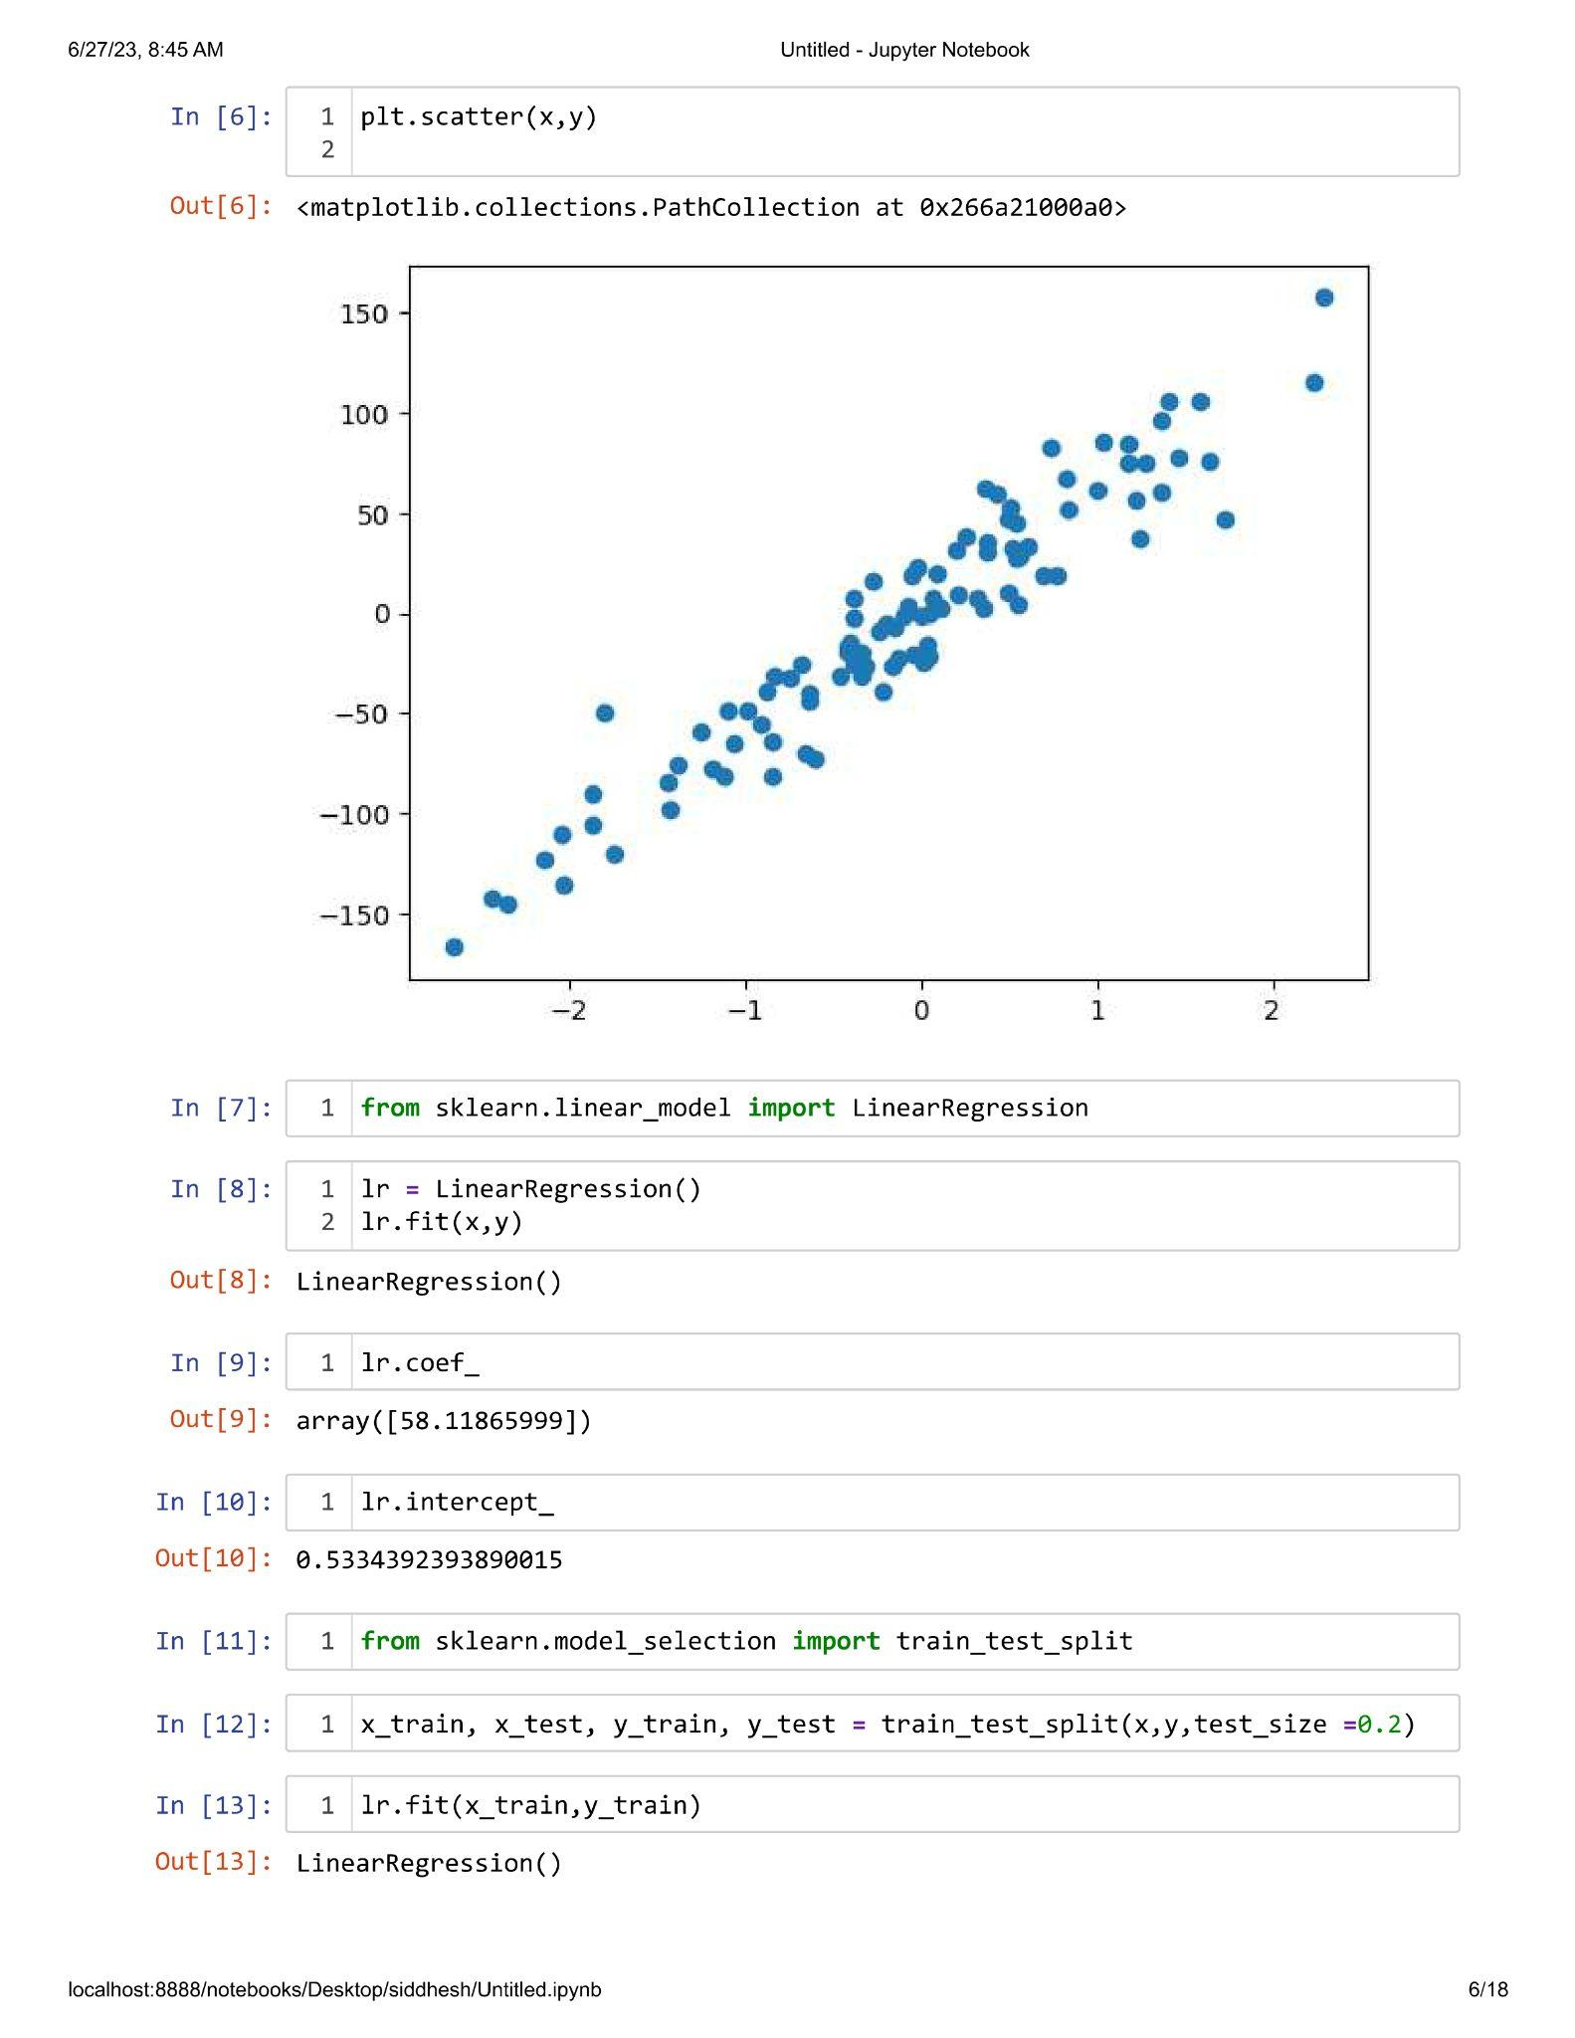

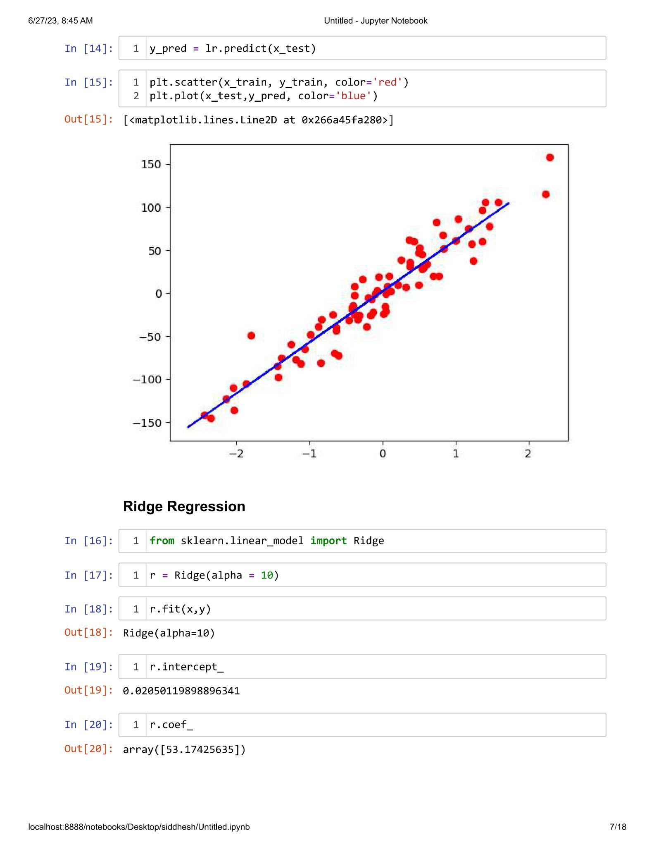

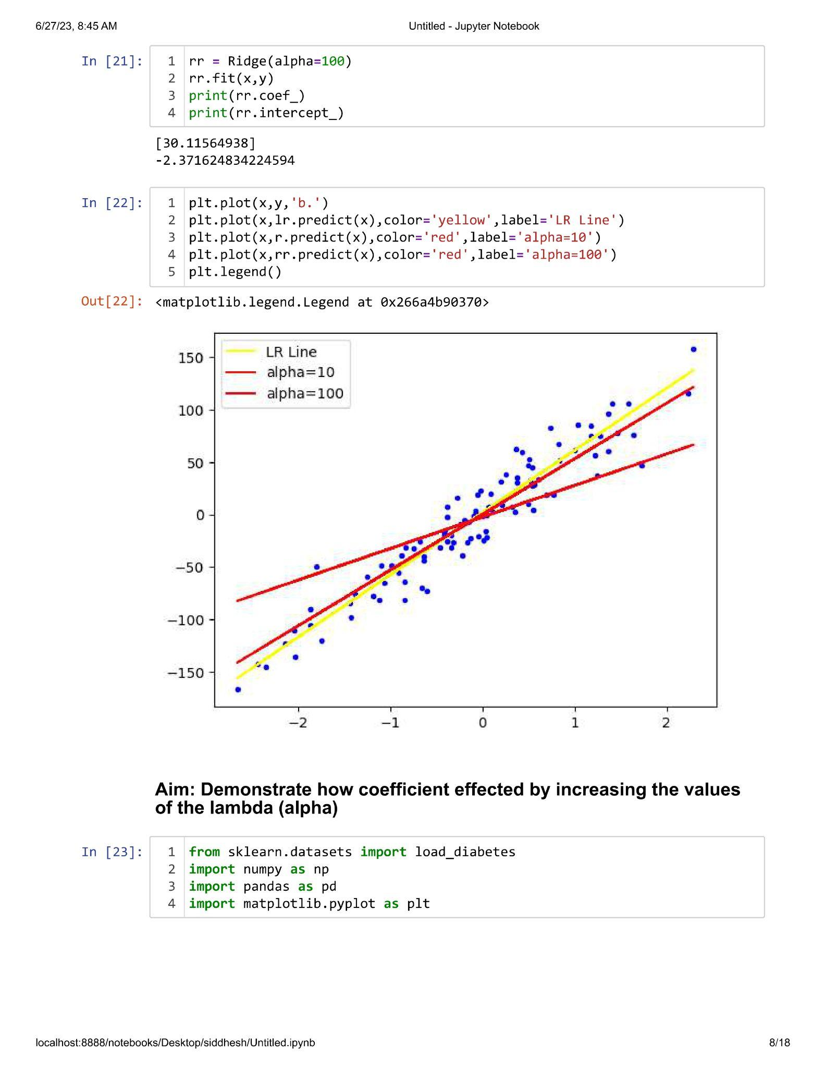

**Practical 2.2**

**Aim : Demonstrate how co-efficient gets affected by increasing values of the lambda(Alpha).**

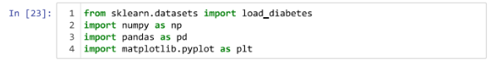



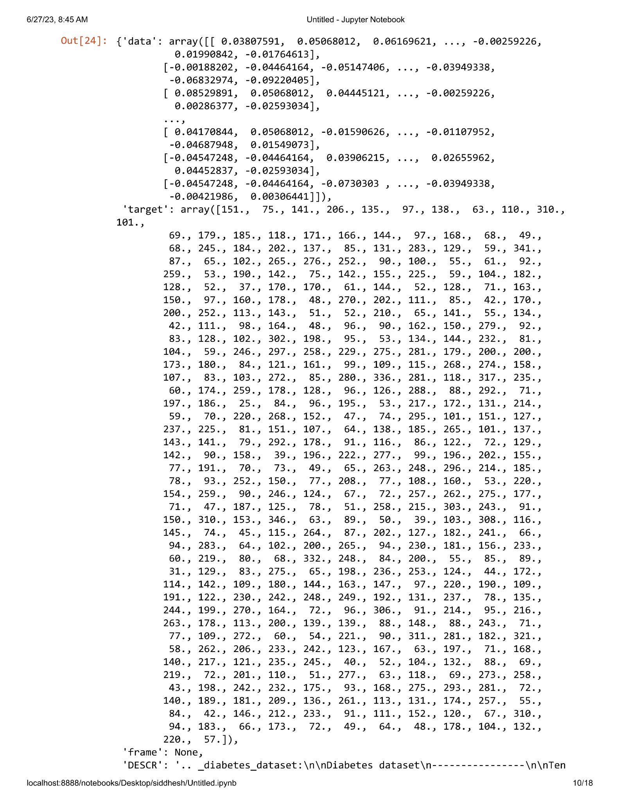

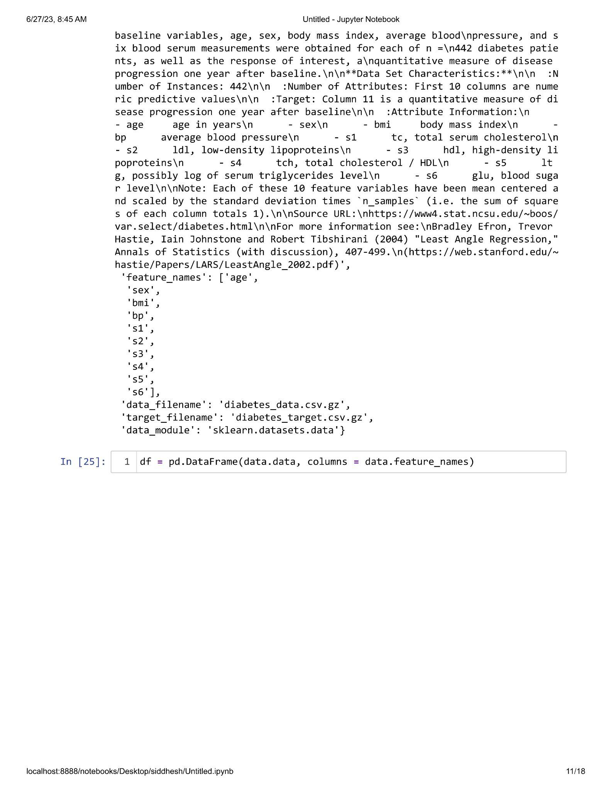

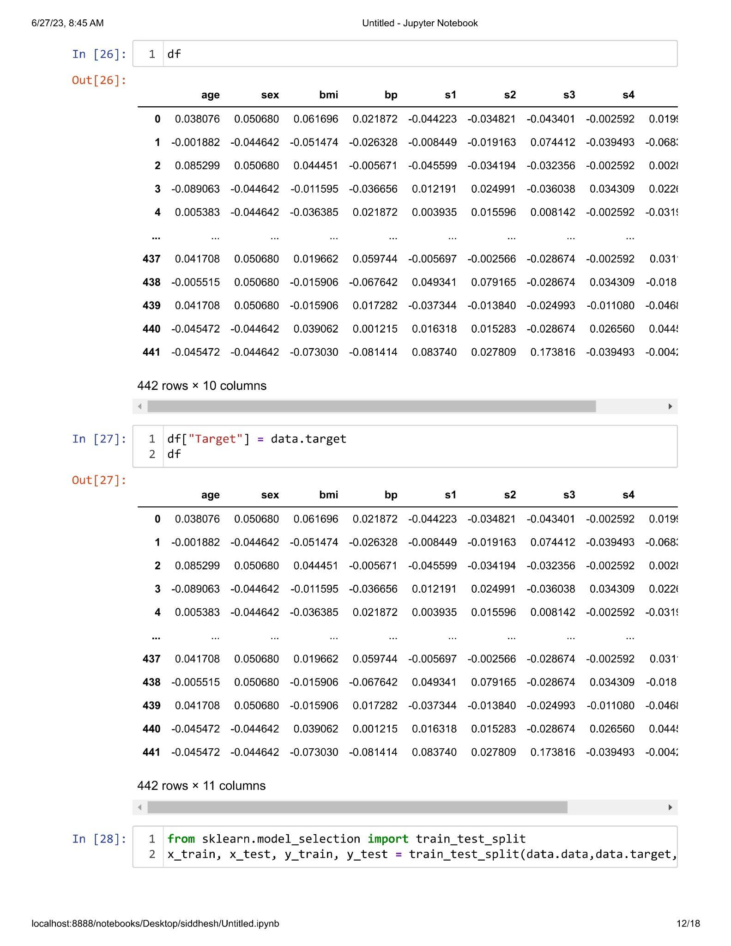

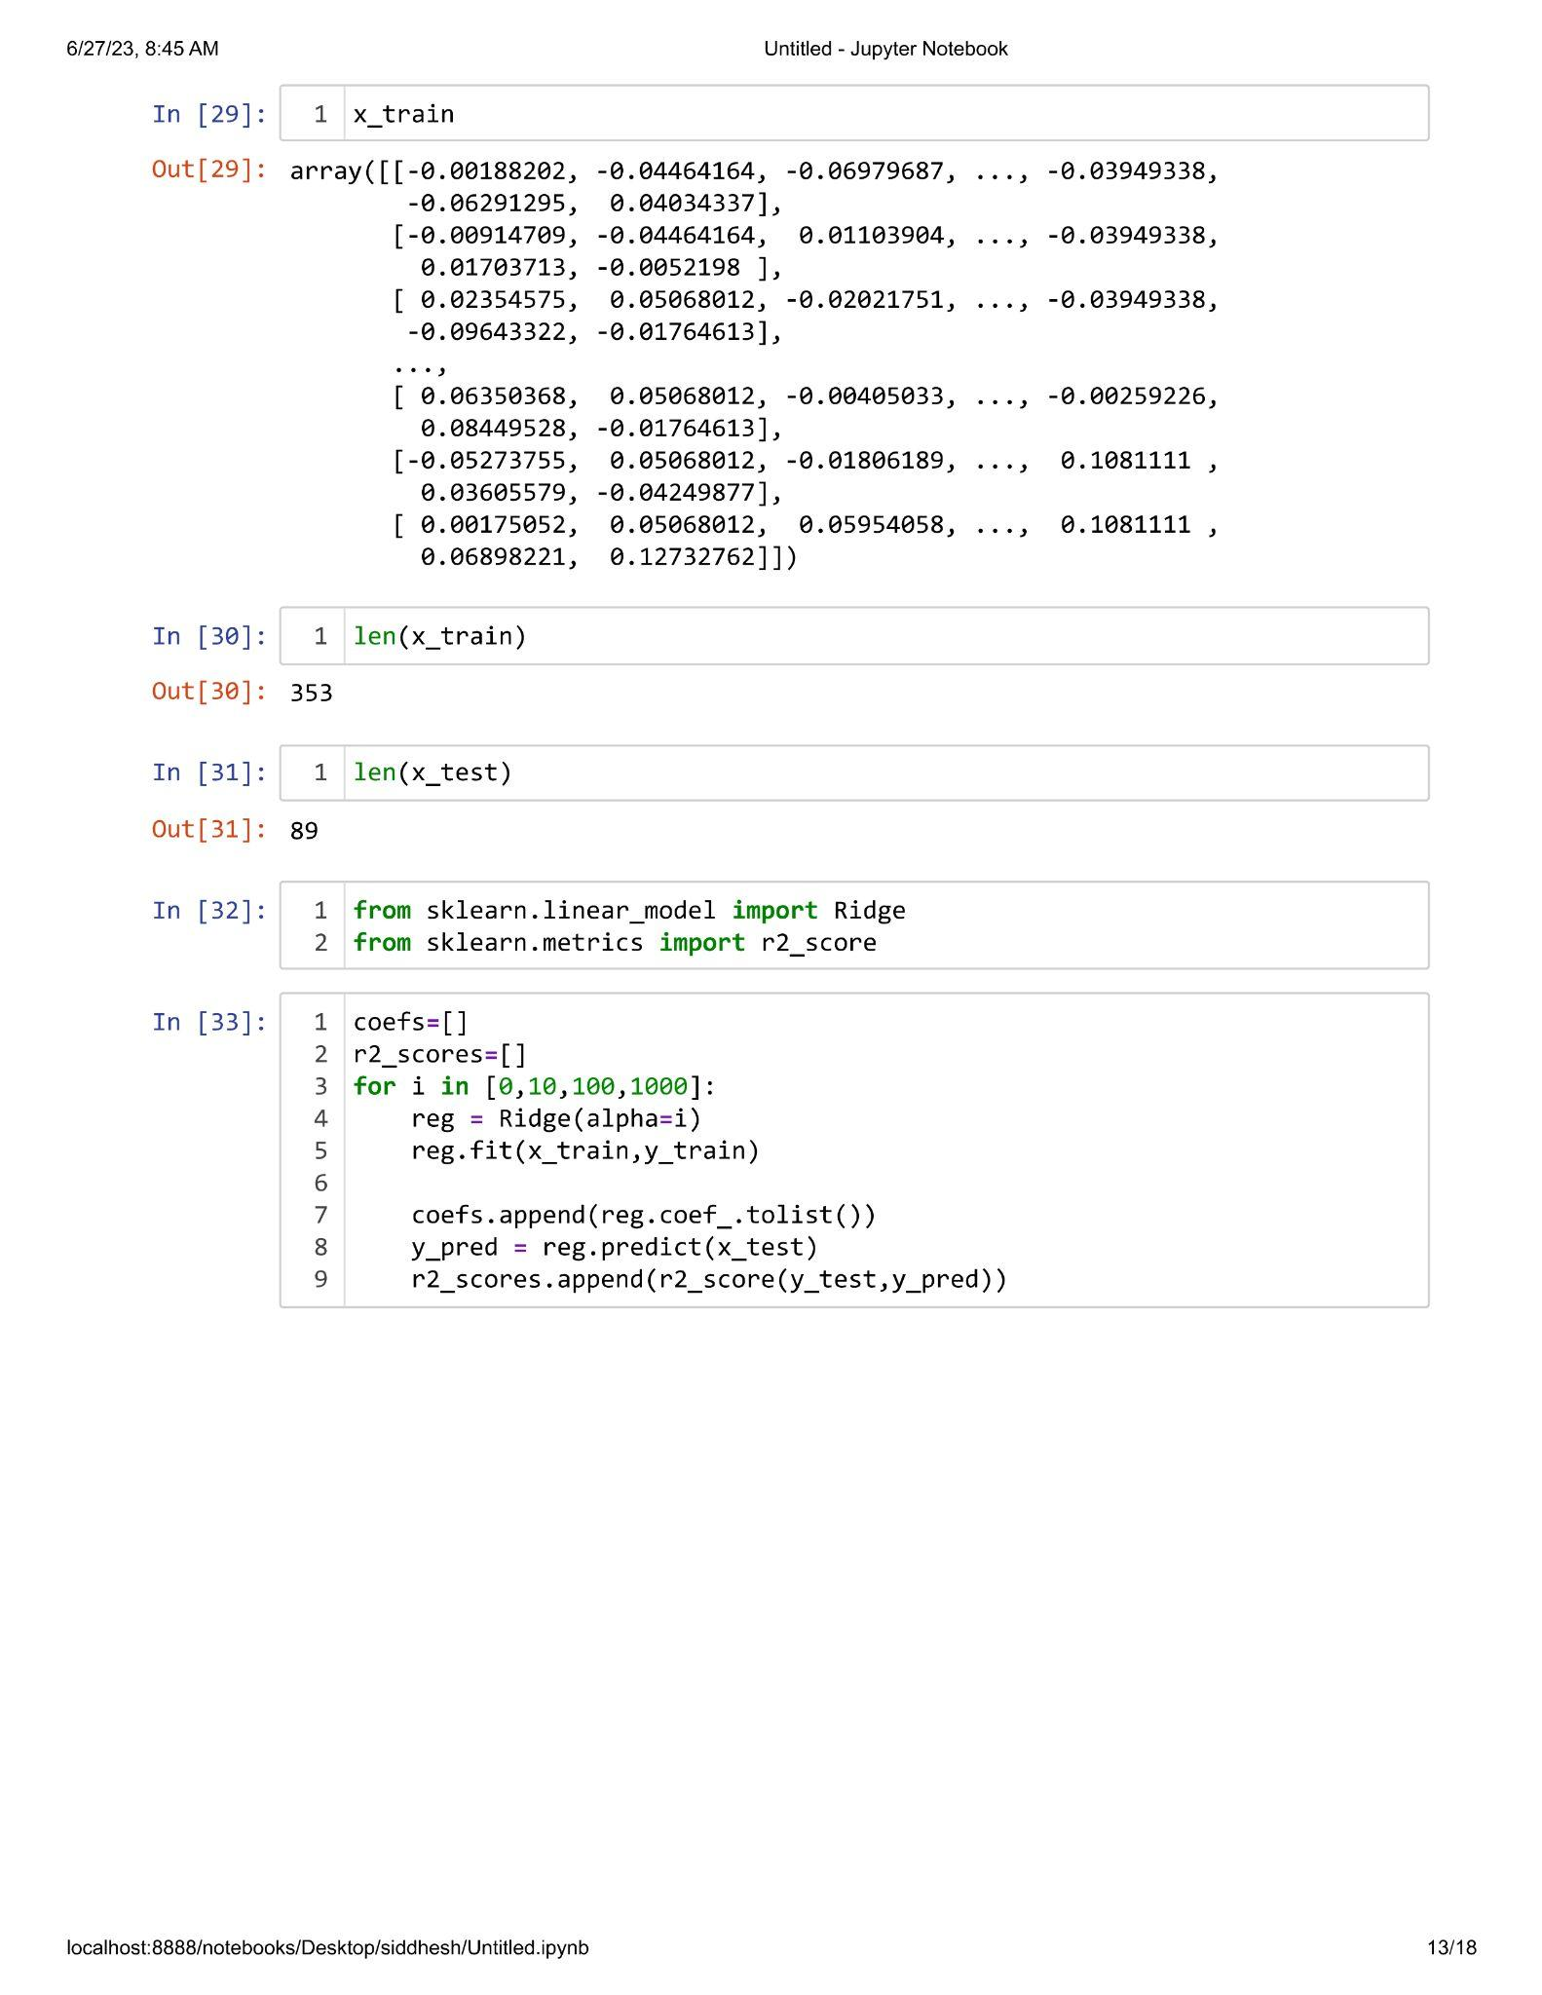

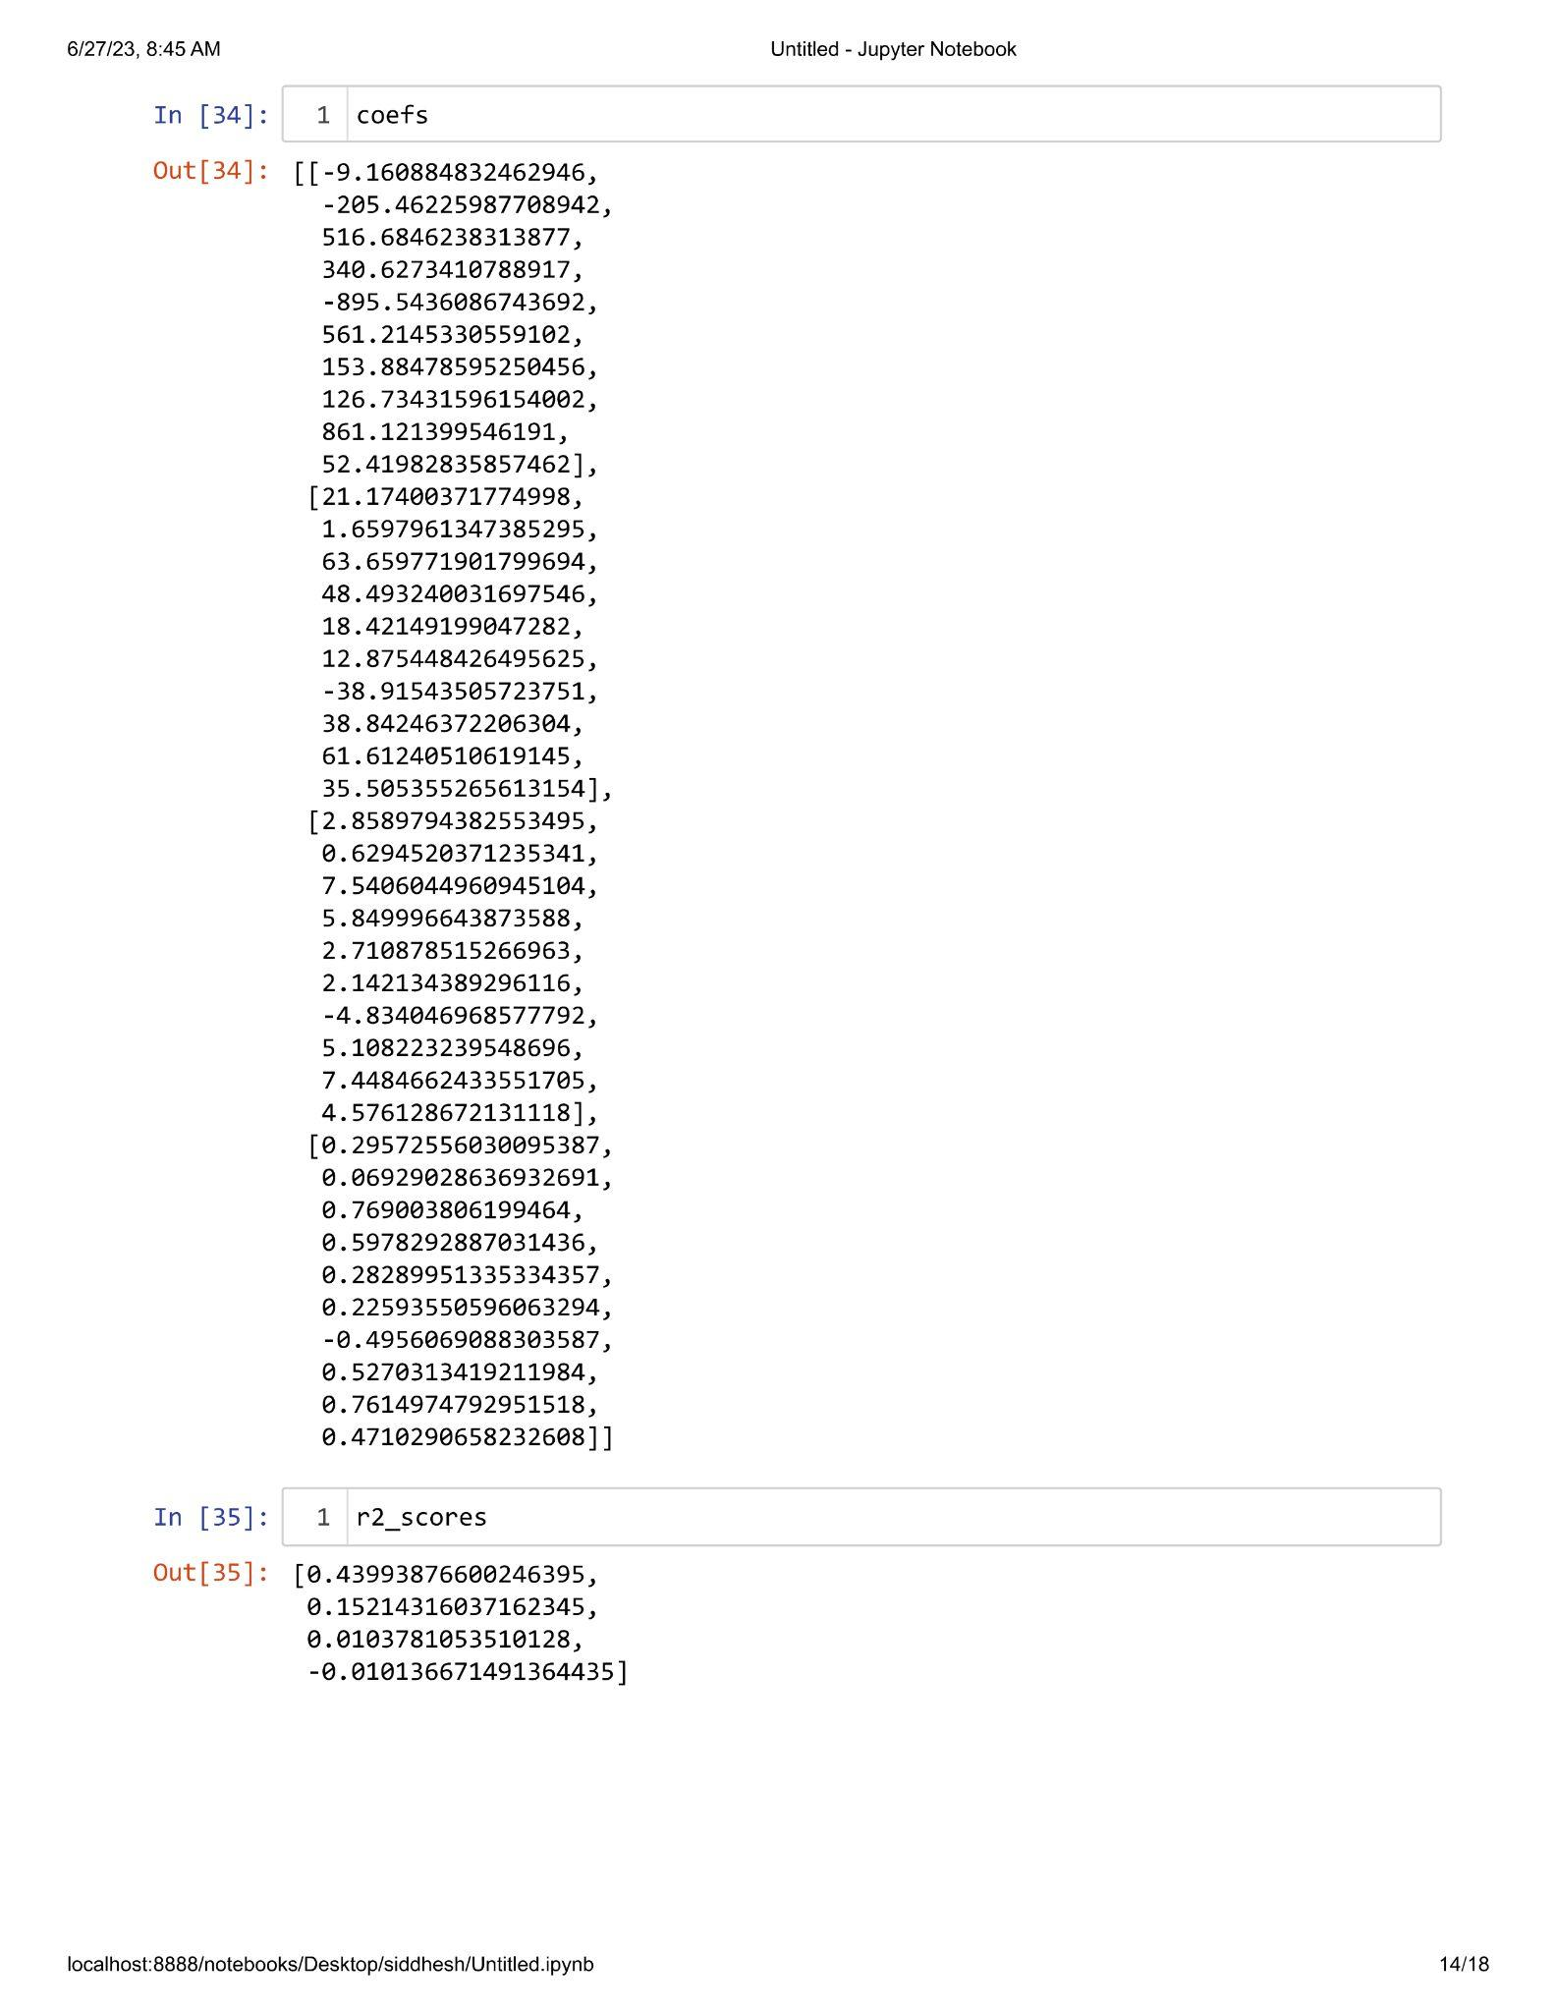

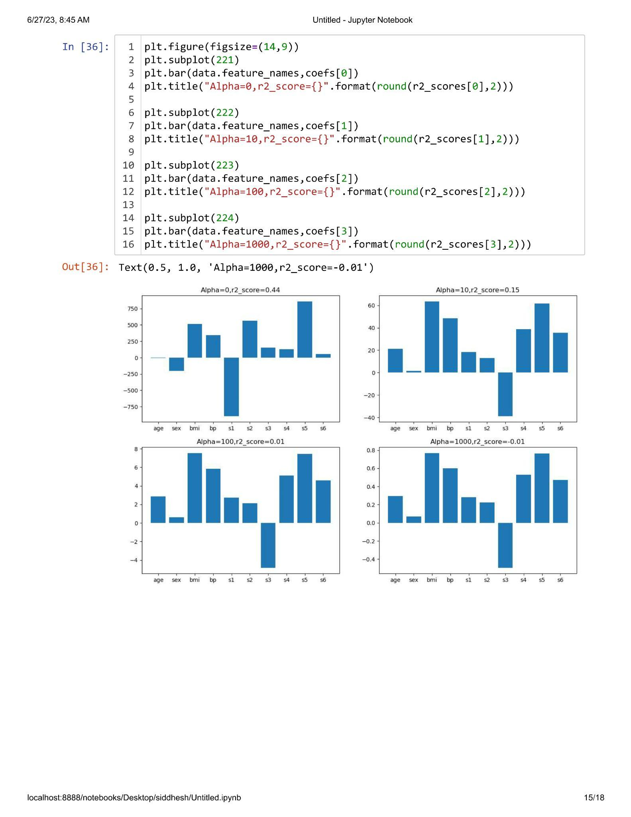

**Practical 2.3**

**Aim : In Ridge Regression prove that 'The more higher co-efficient are affected more'.**

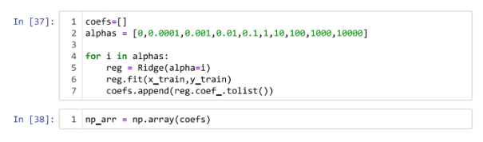

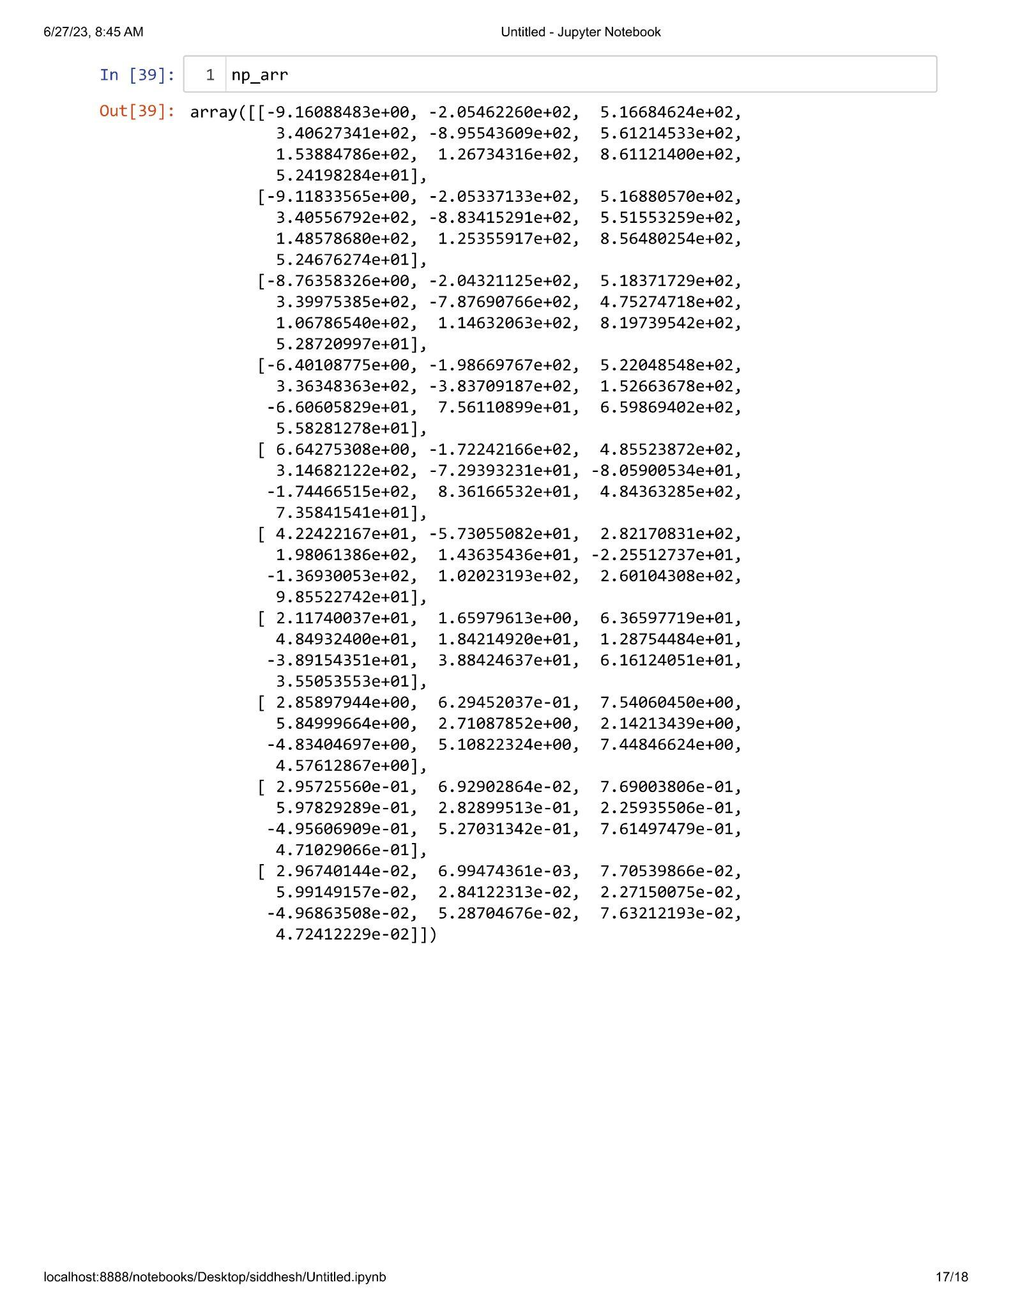

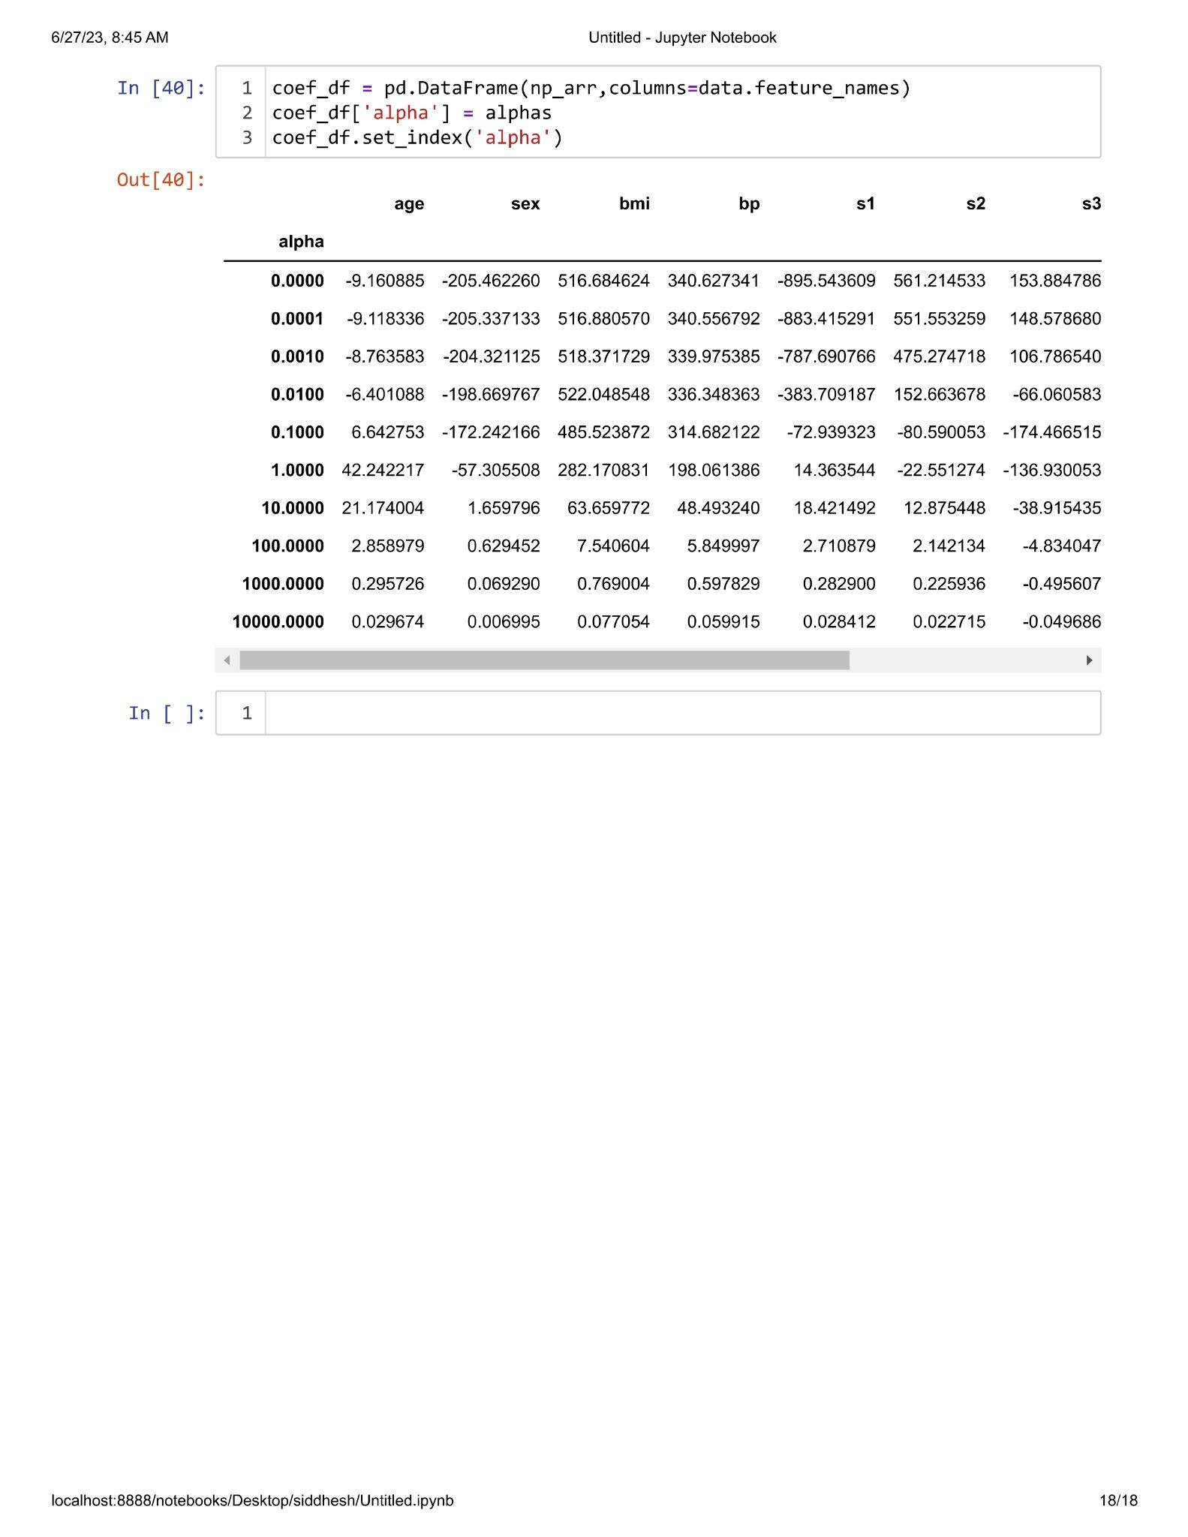

**Practical 2.4**

**Aim : Implementation of LASSO Regression.**

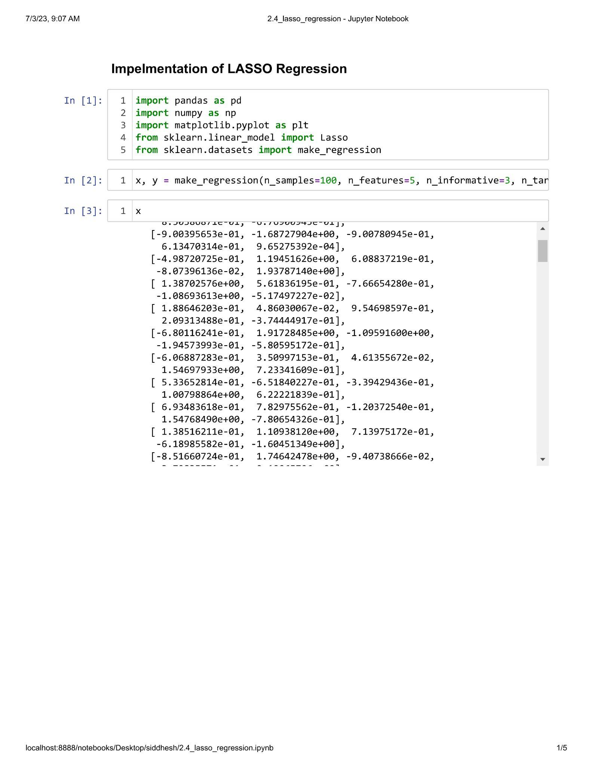

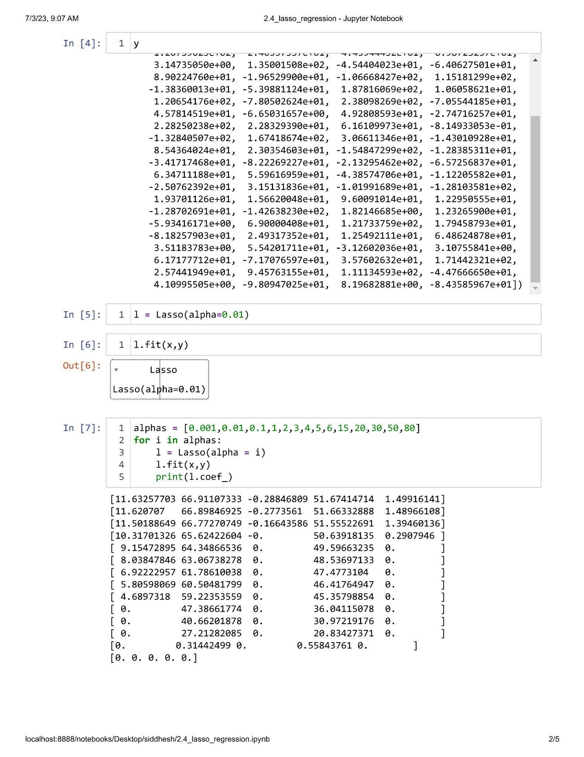

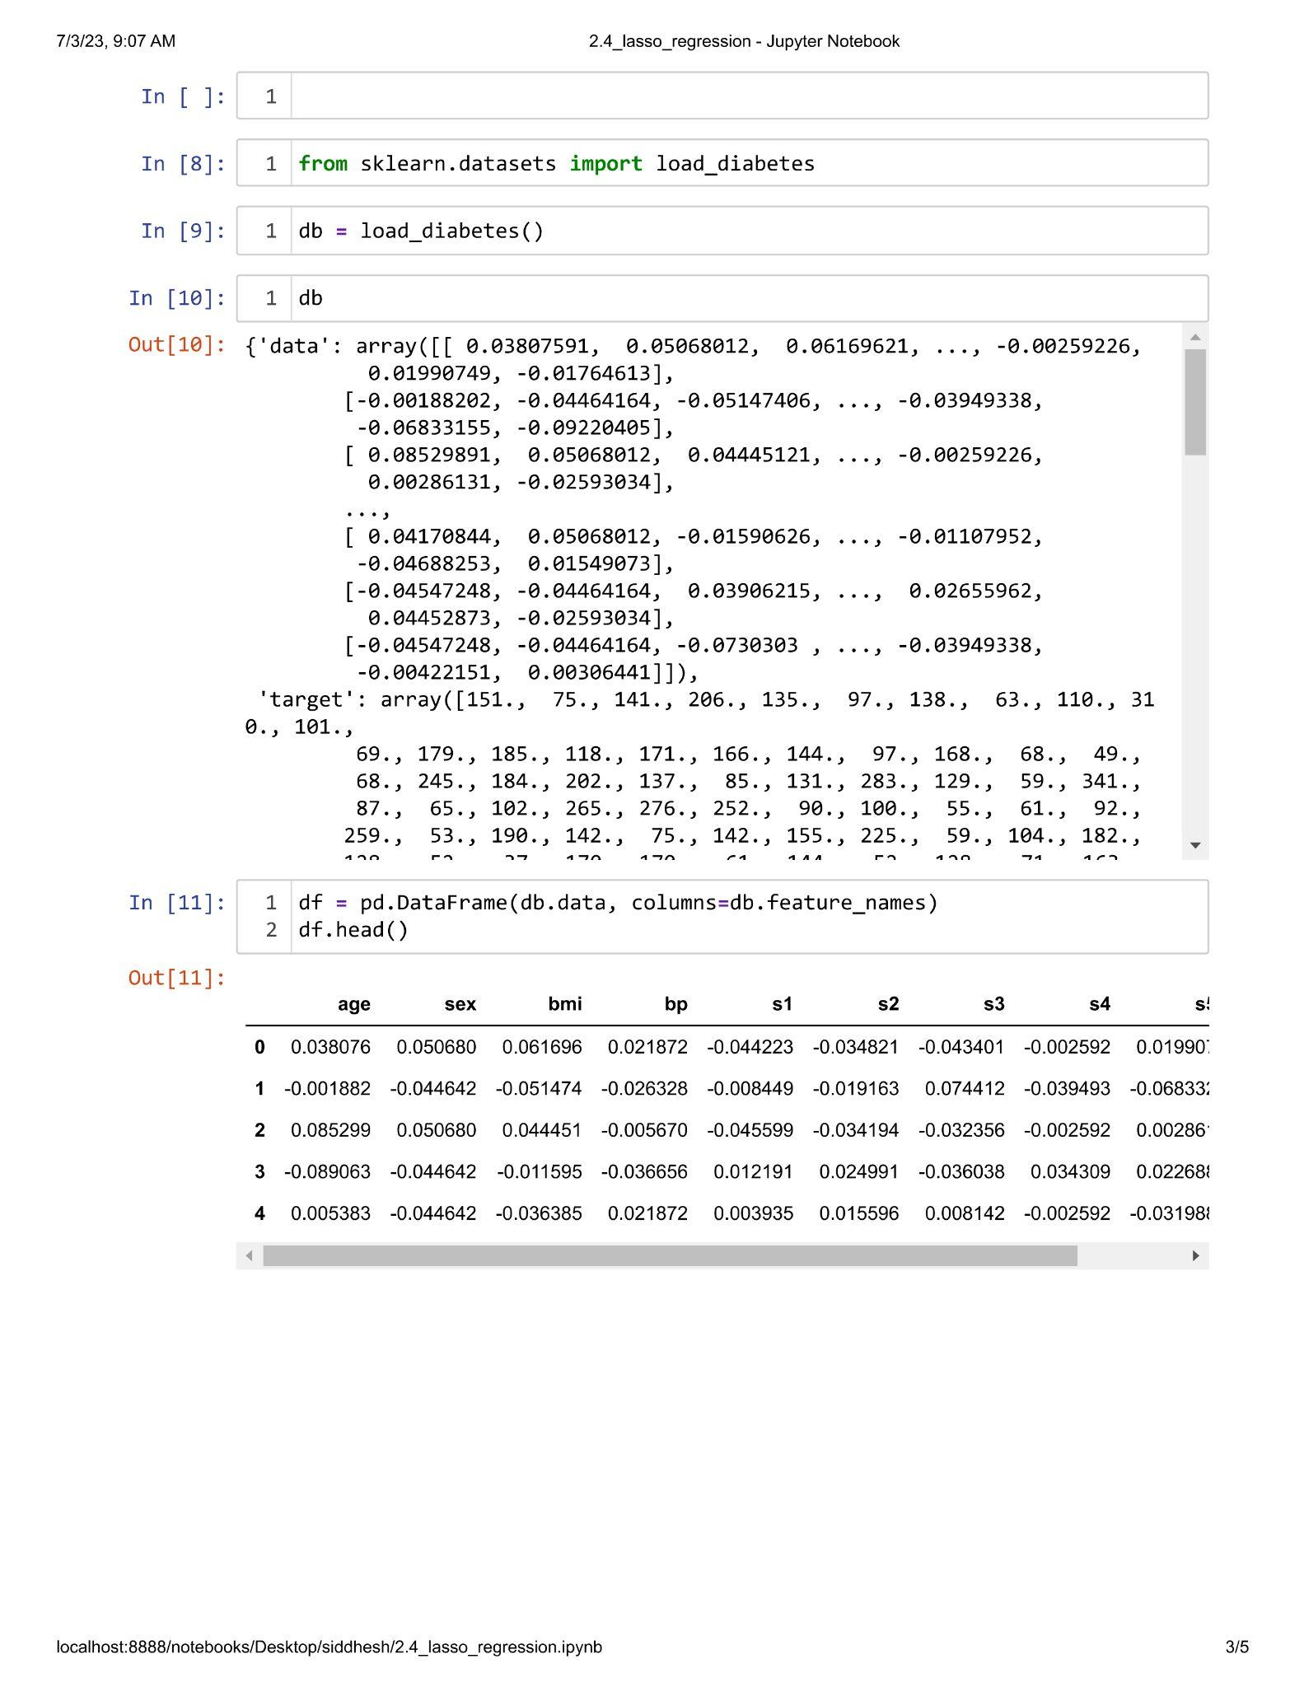

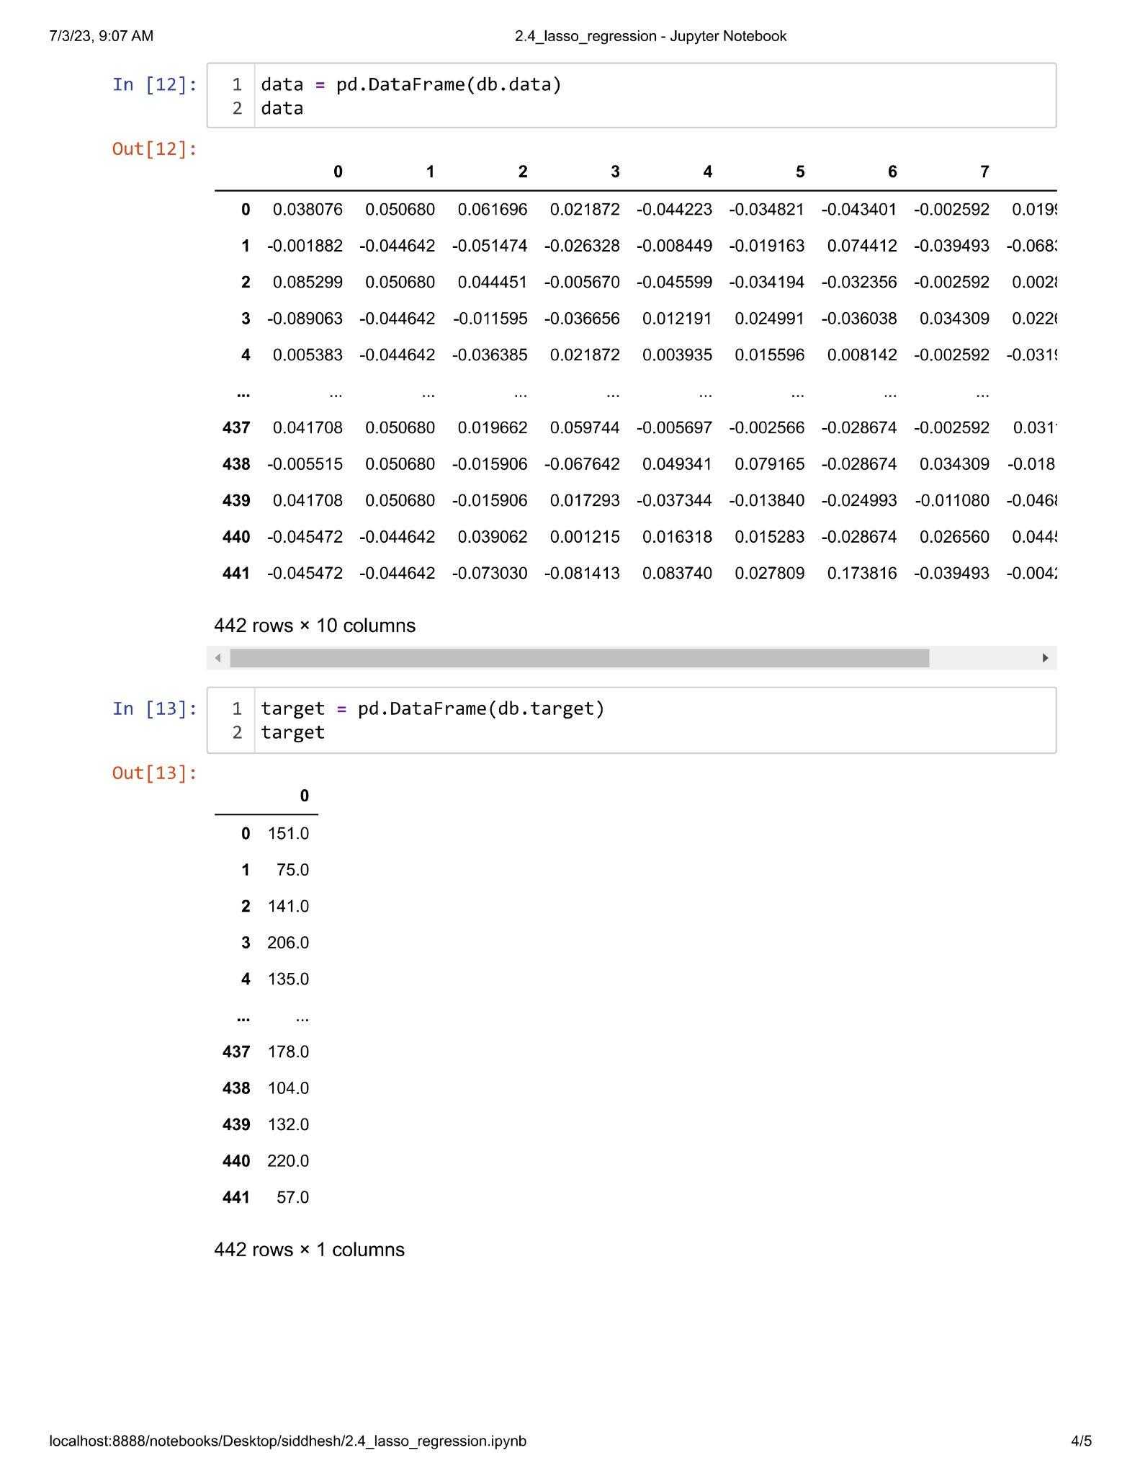

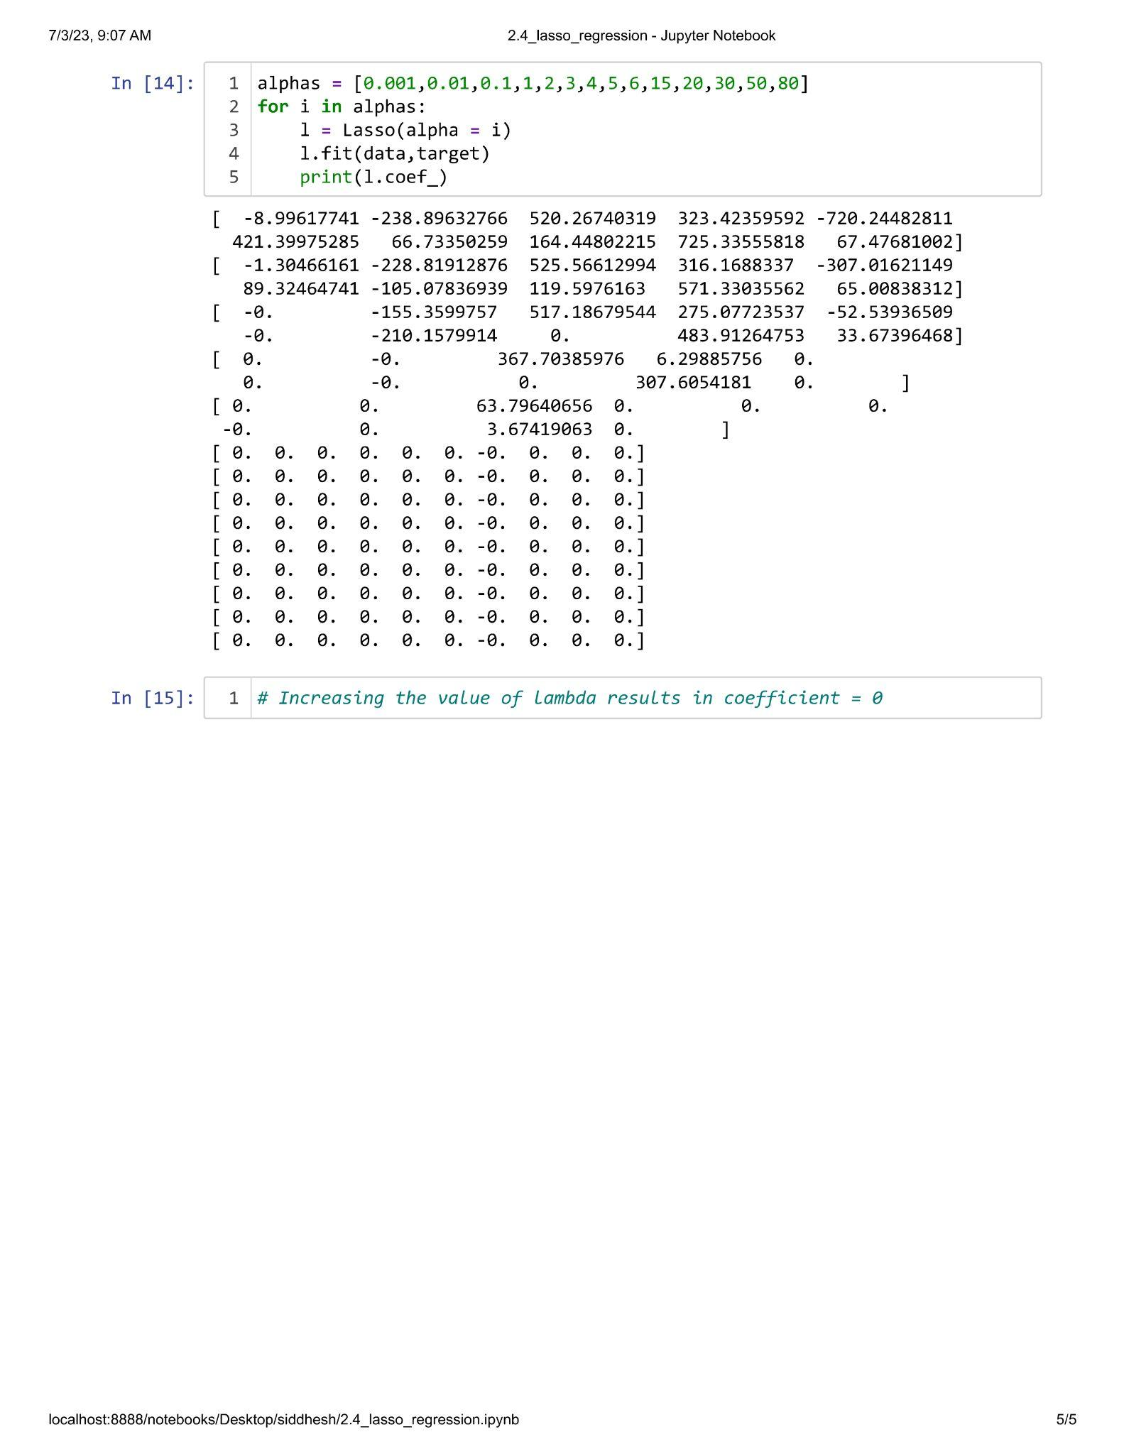

**Unit III**

**Practical 3.1**

**Aim : Implementation of Voting Ensemble Learning.**

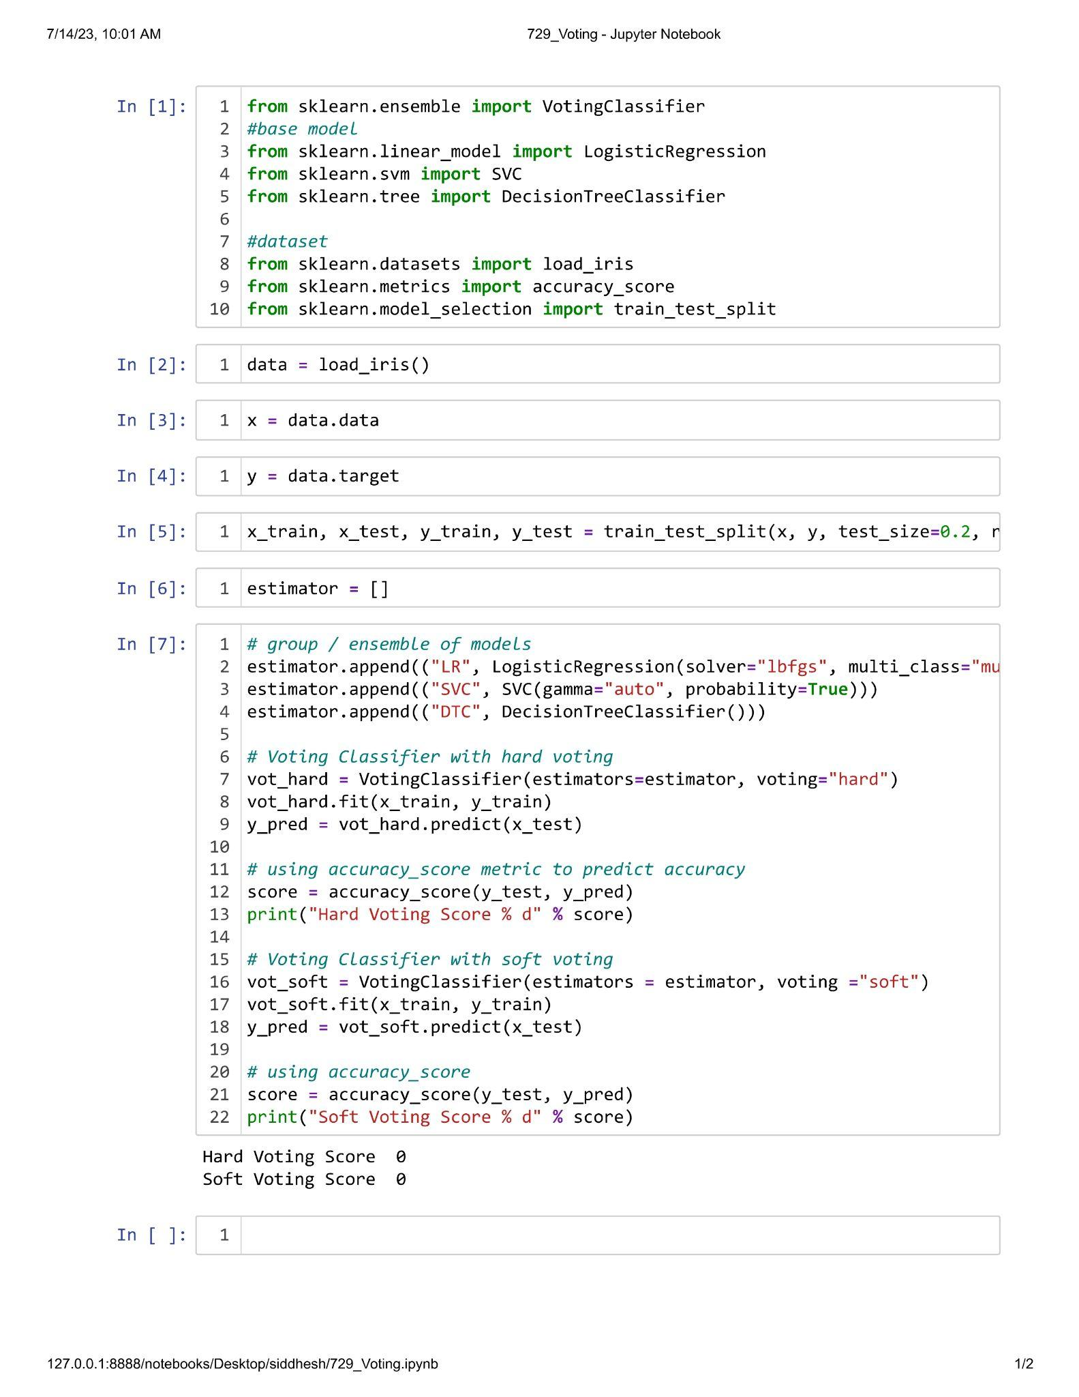

**Practical 3.2**

**Aim : Implementation of Bagging Technique.**

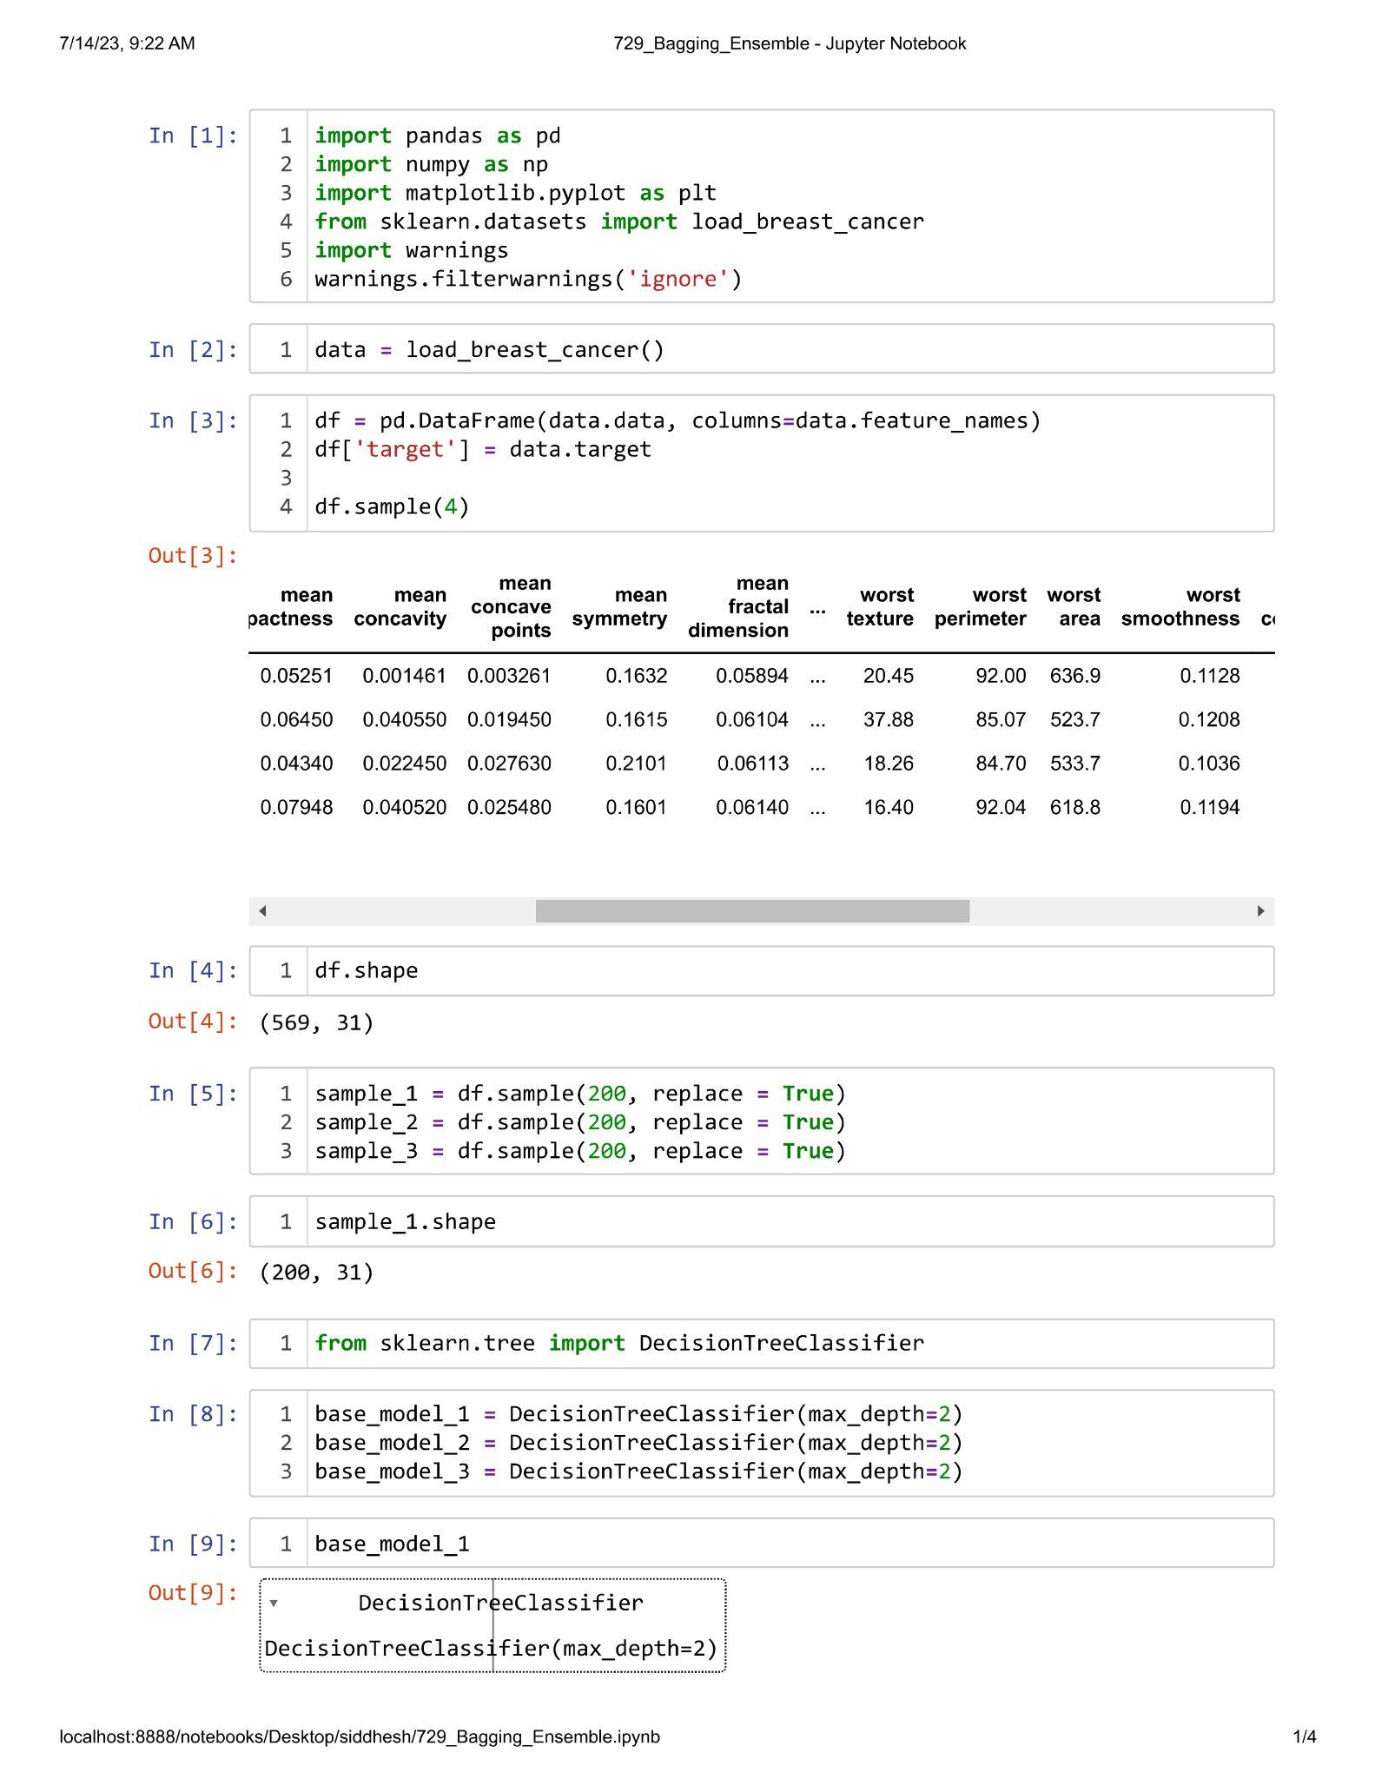

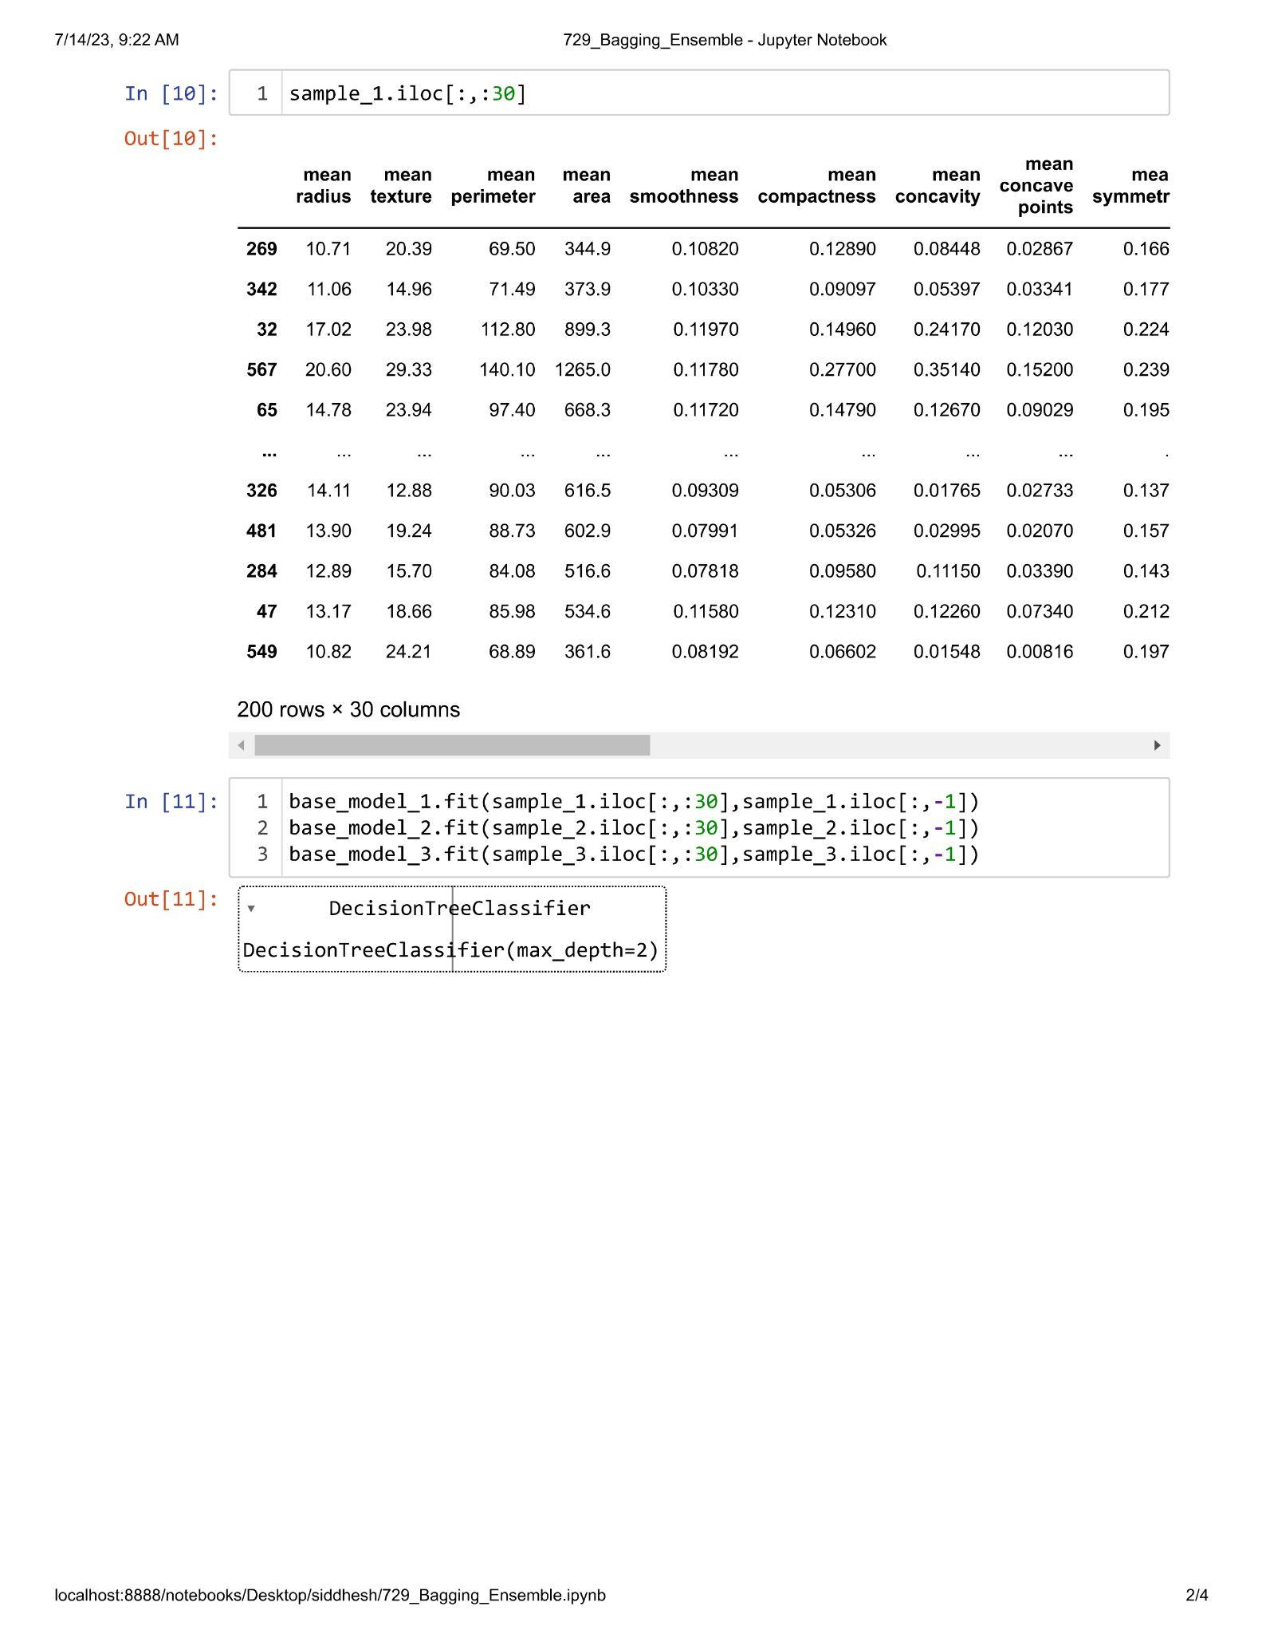

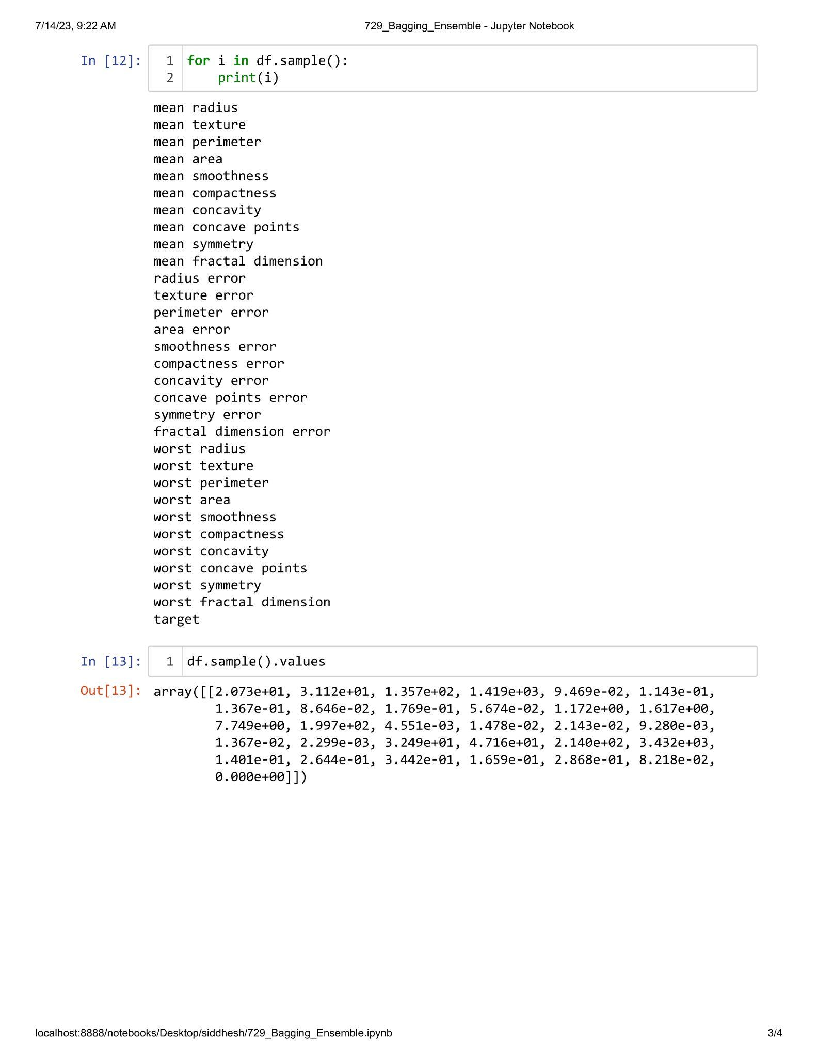

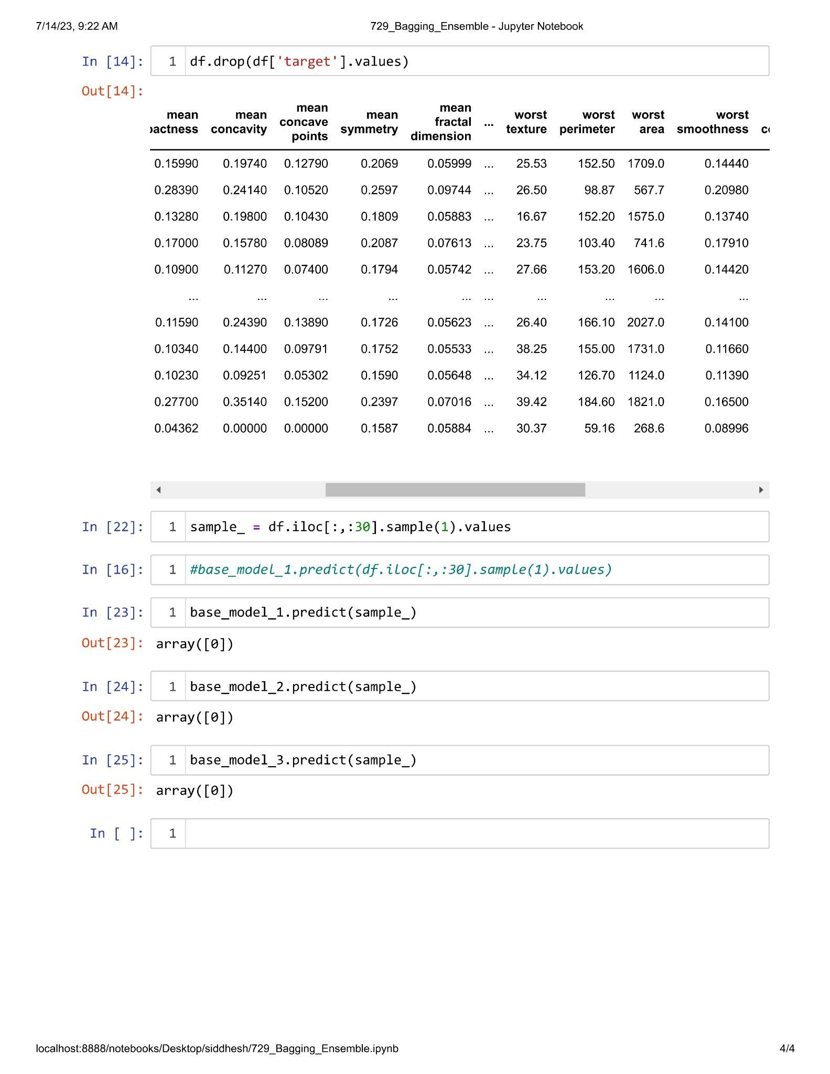

**Practical 3.3**

**Aim : Implementation of Gradient Boosting Algorithm.**

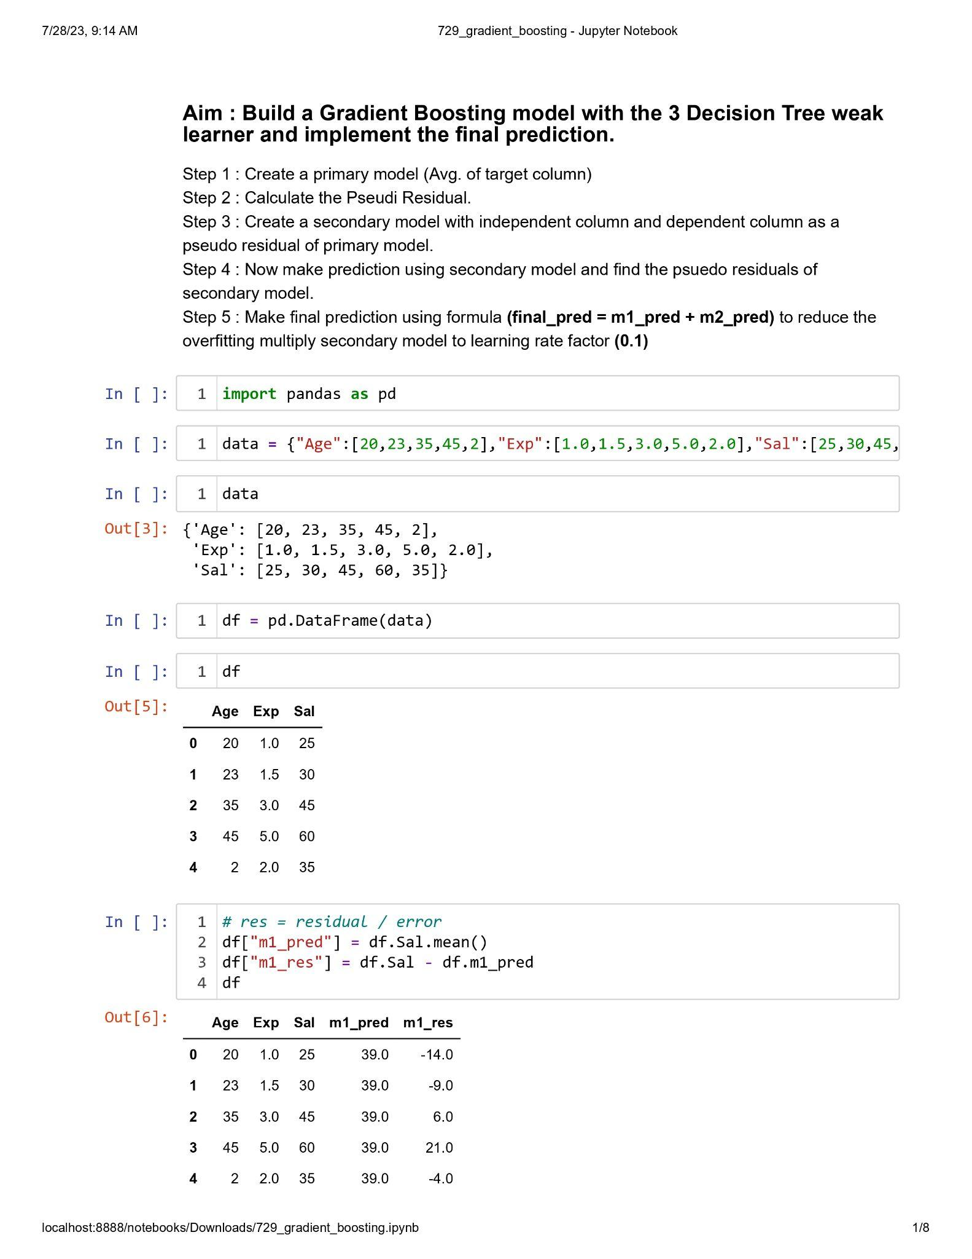

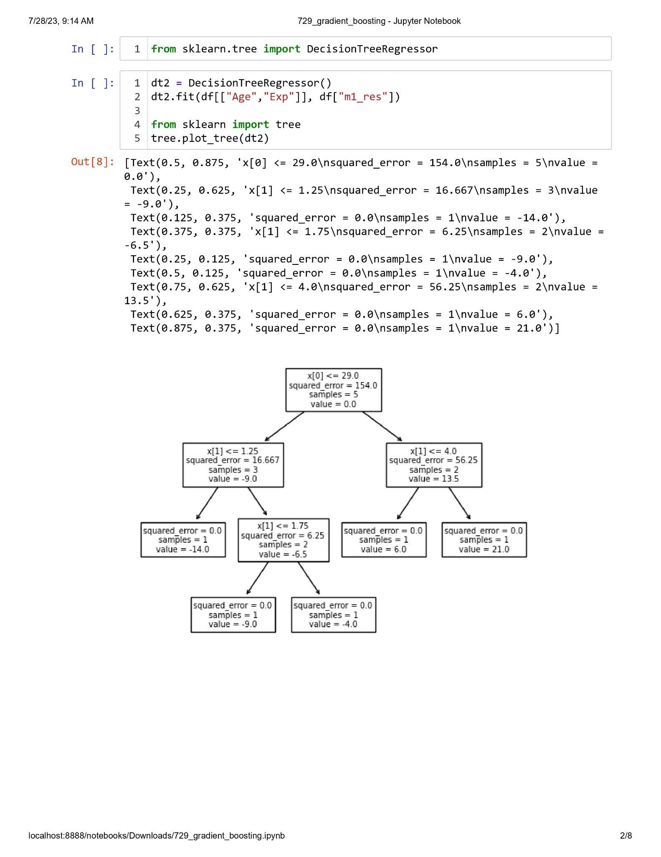

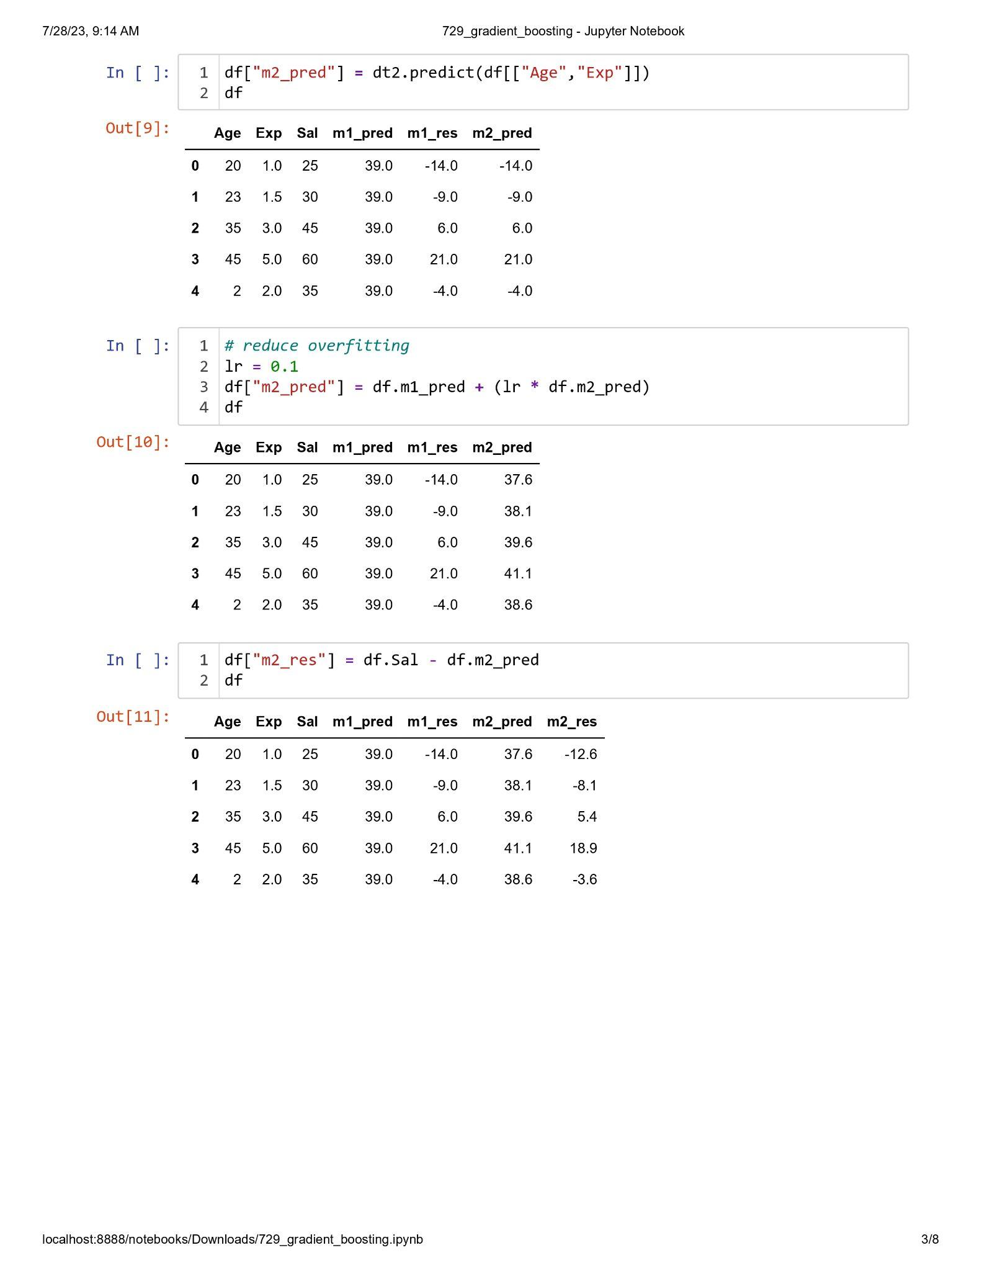

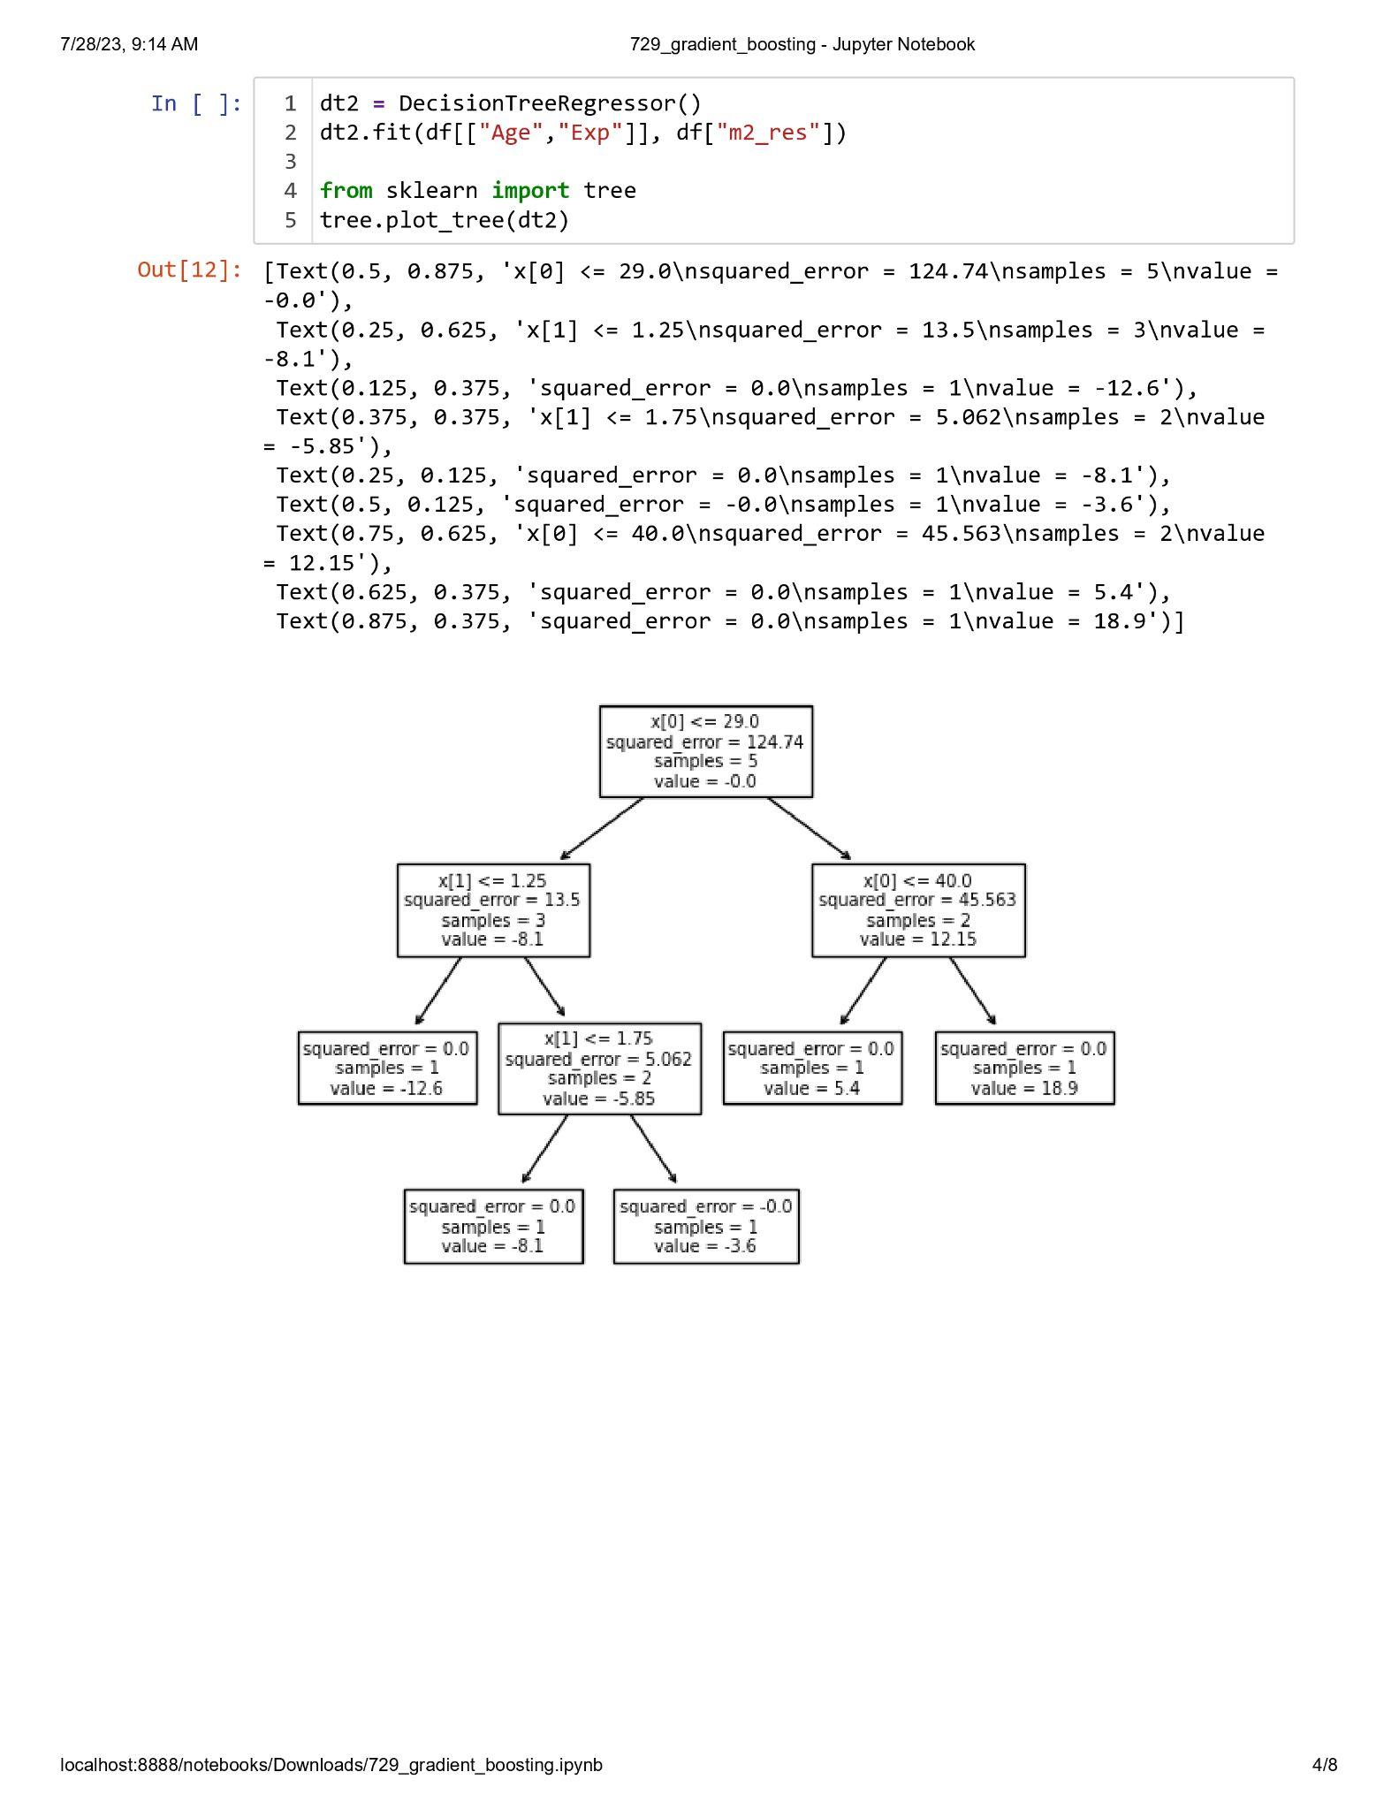

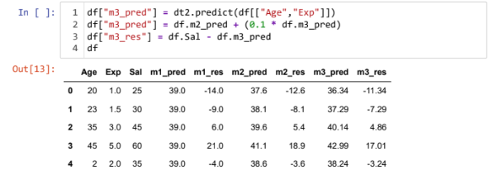

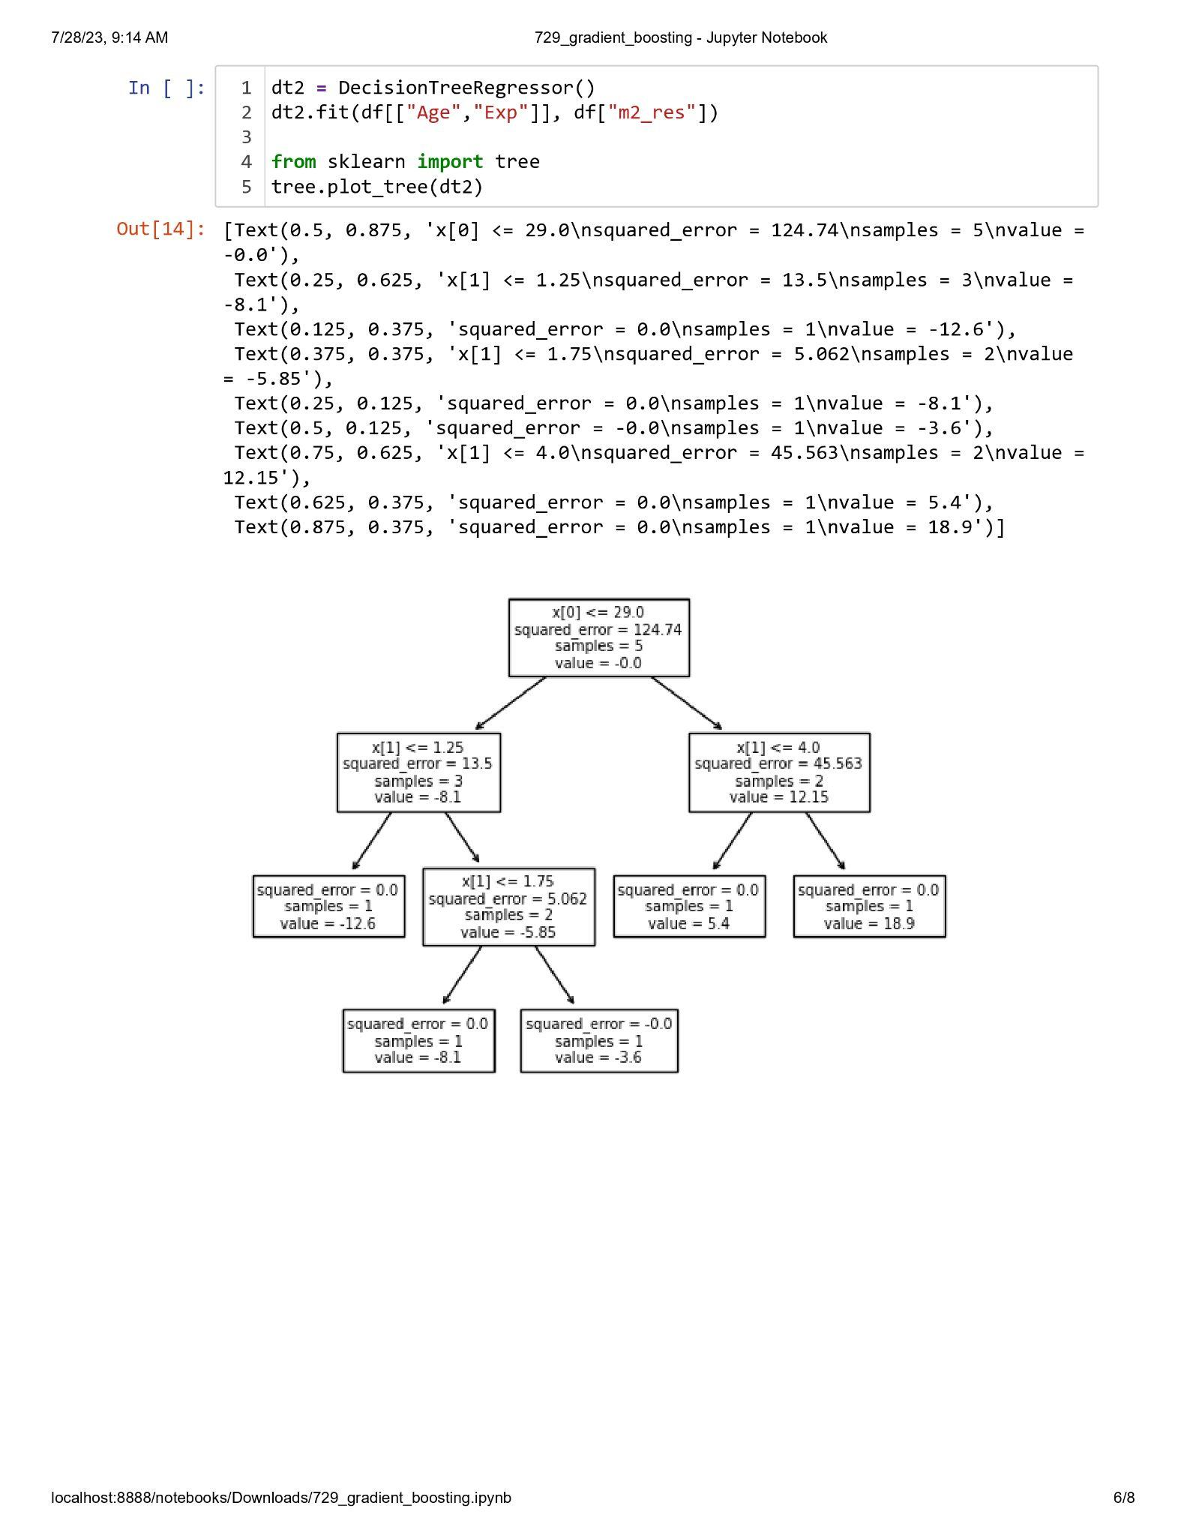

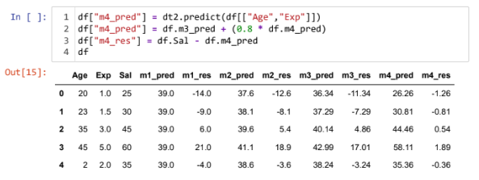

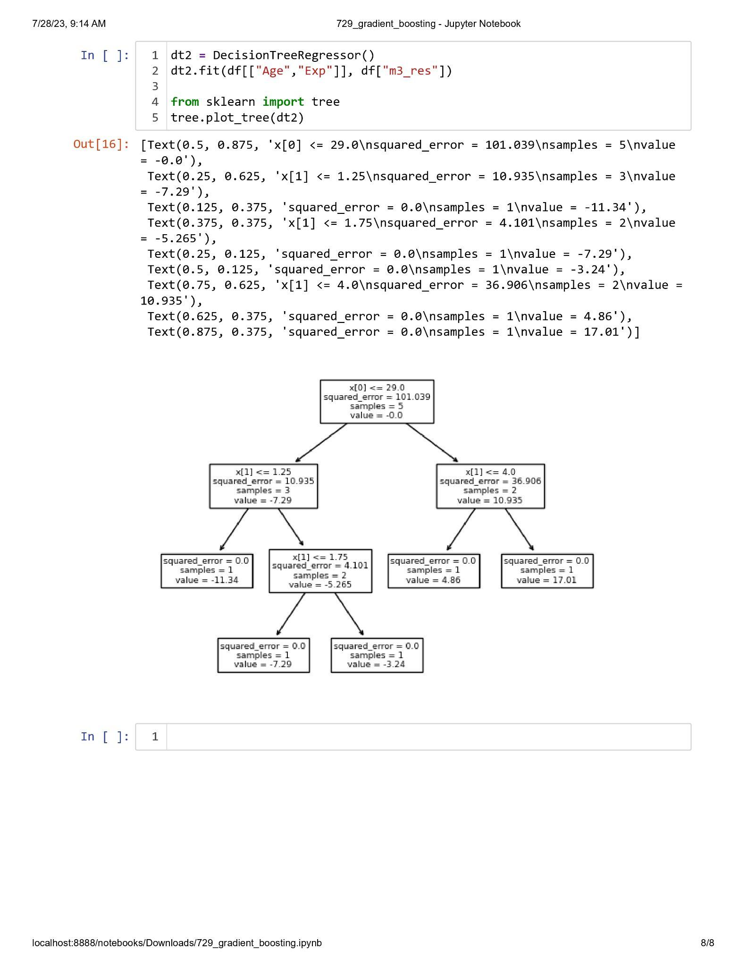

**Practical 3.4**

**Aim : Implementation of Stacking.**

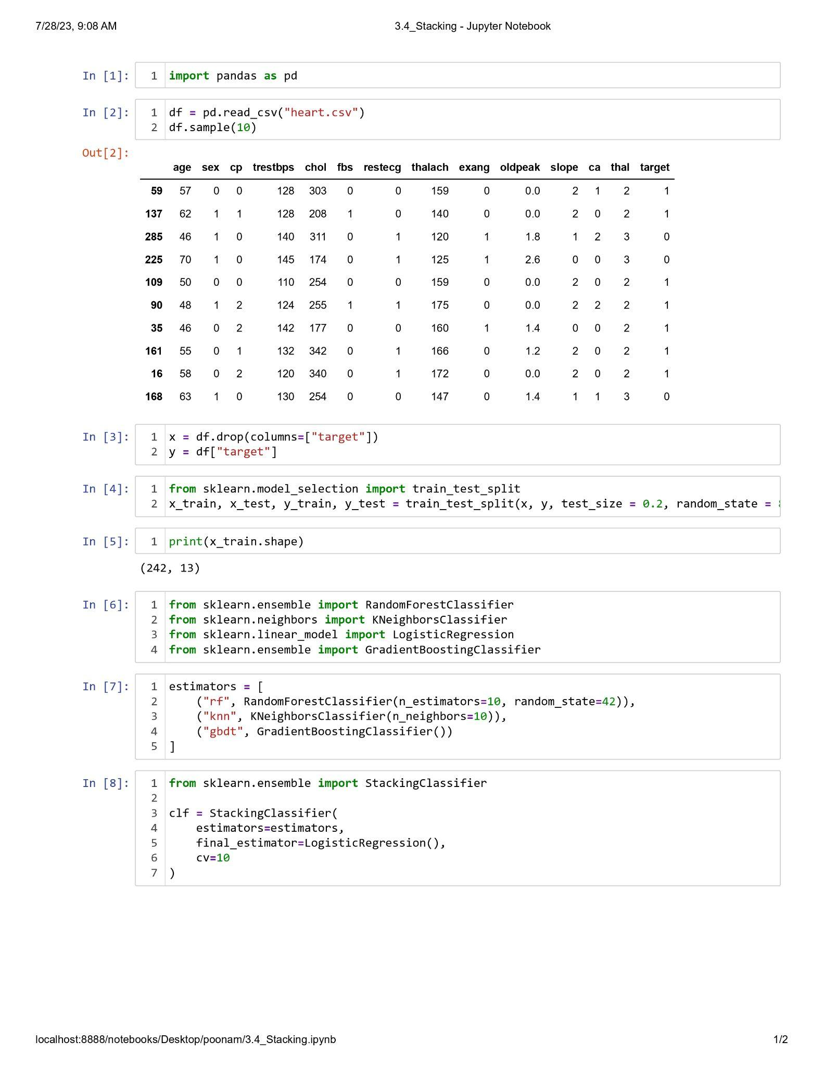

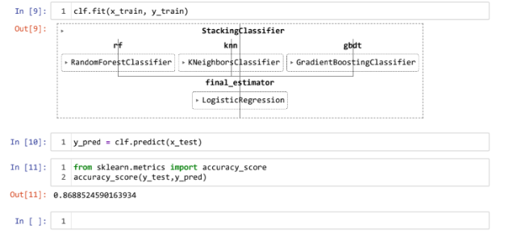

**Practical 3.5**

**Aim : Implementation of K-means Clustering.**

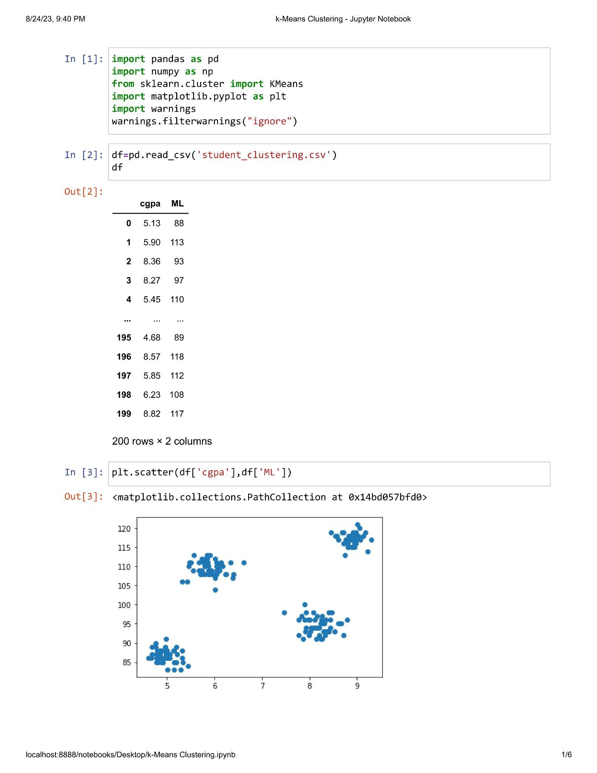

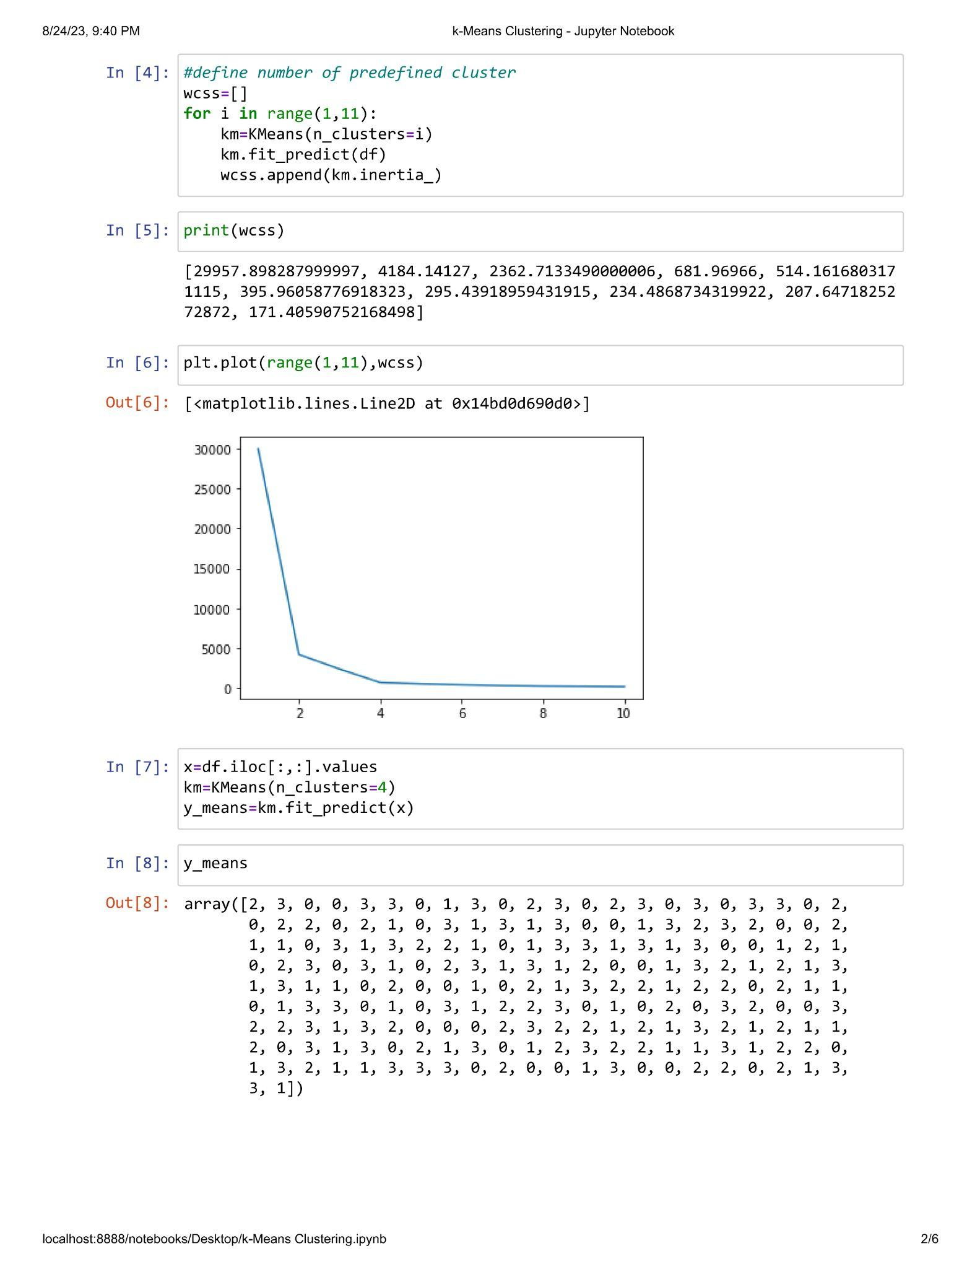

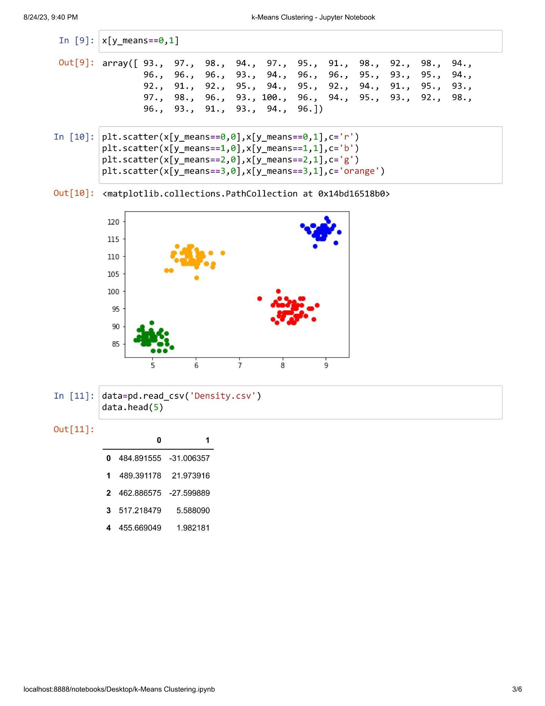

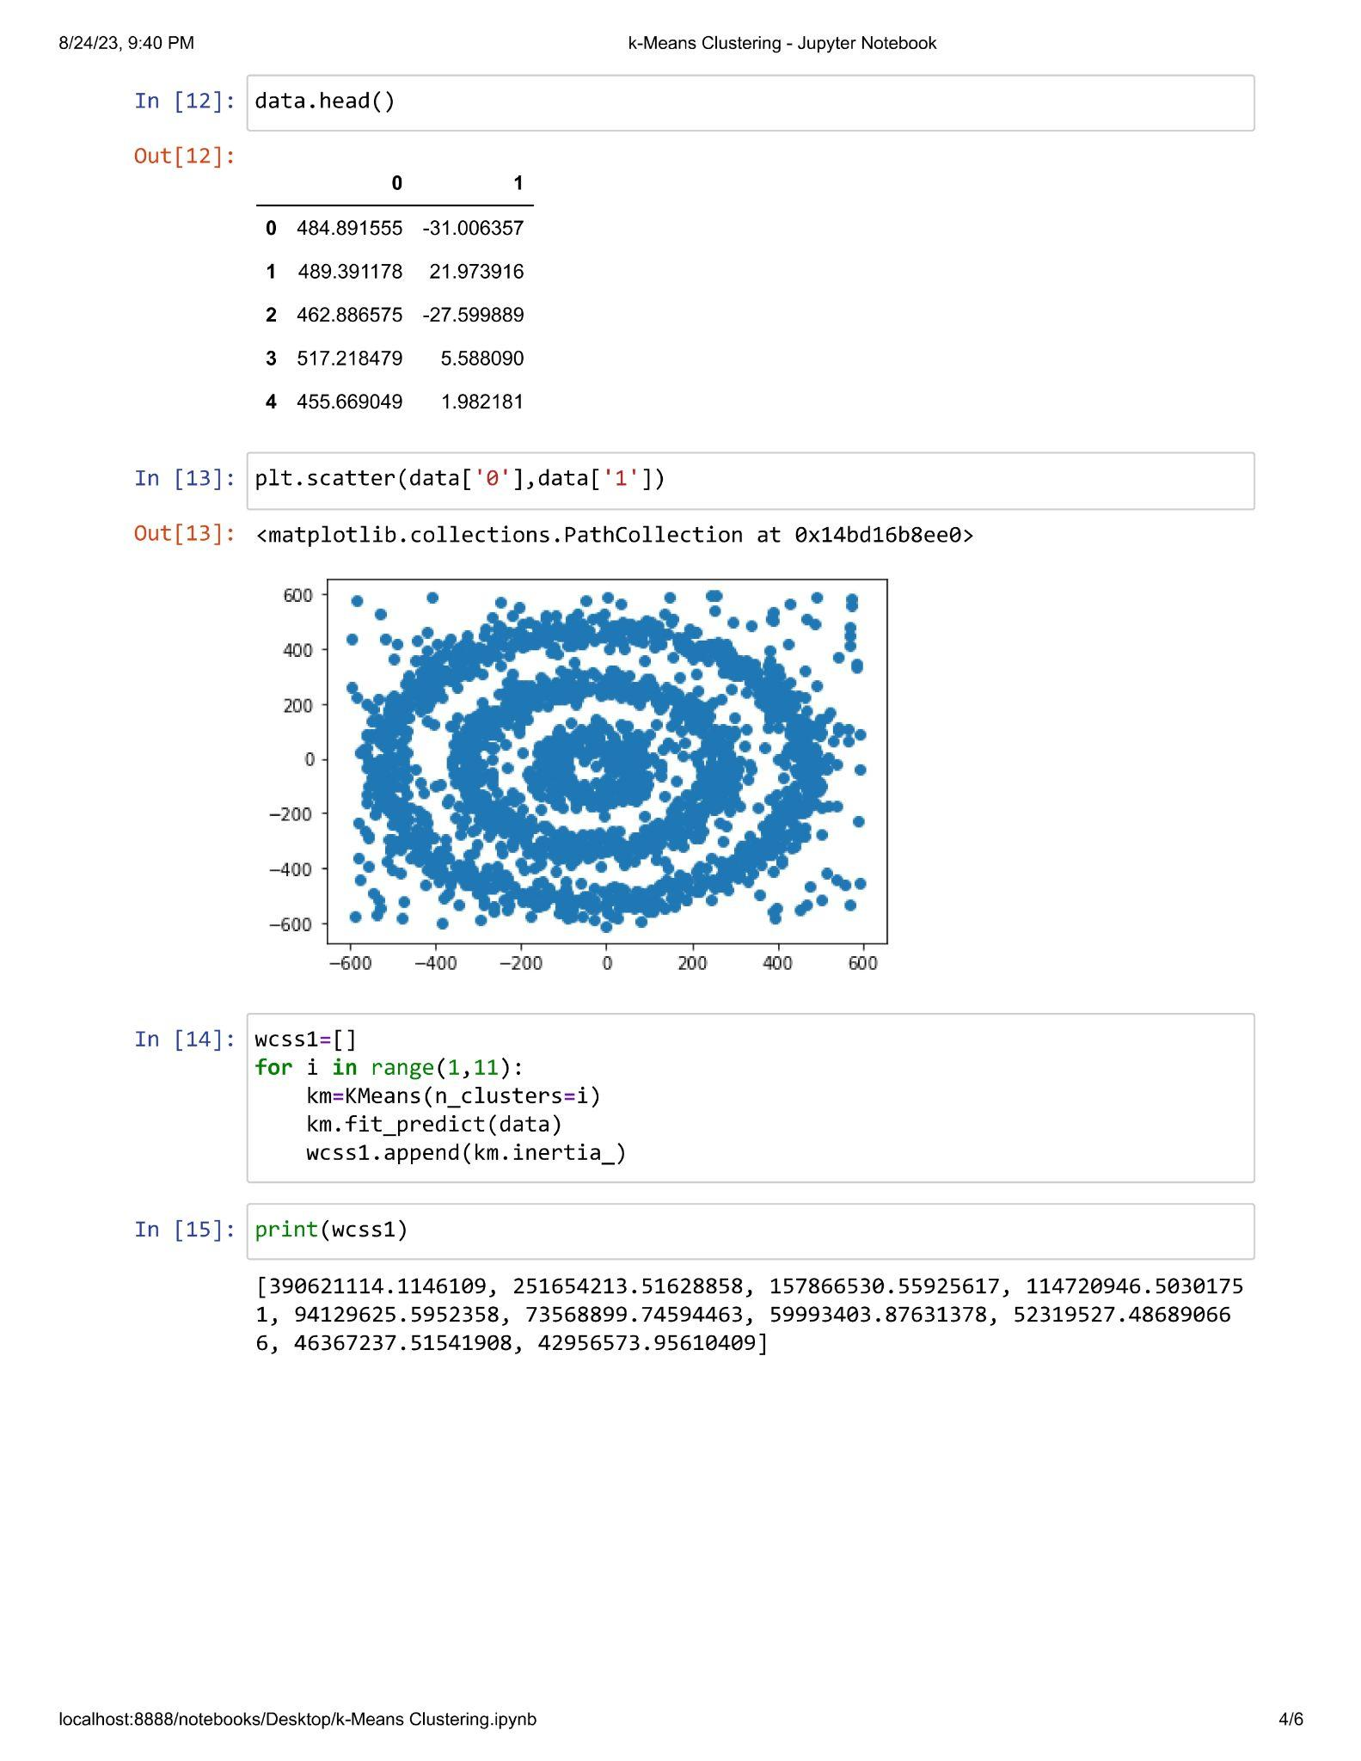

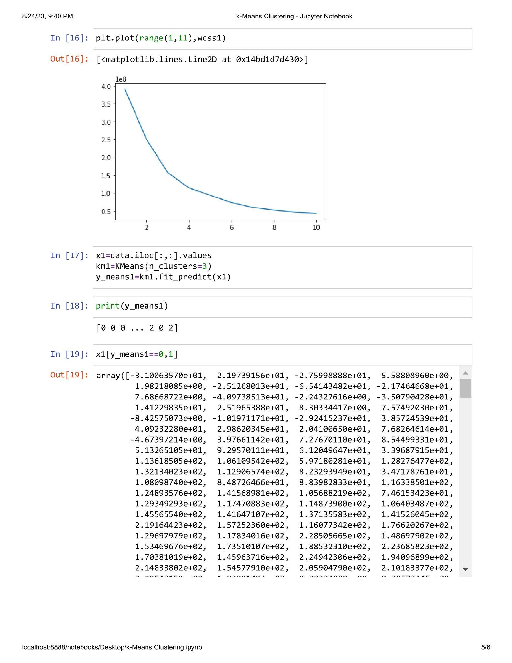

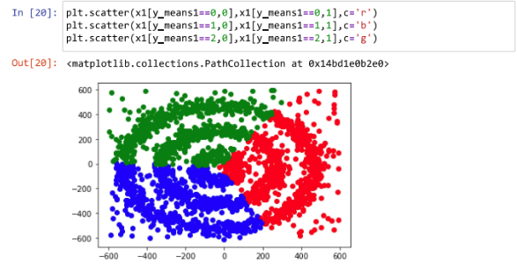

**Practical 3.6**

**Aim : Implementation of Agglomerative Clustering.**

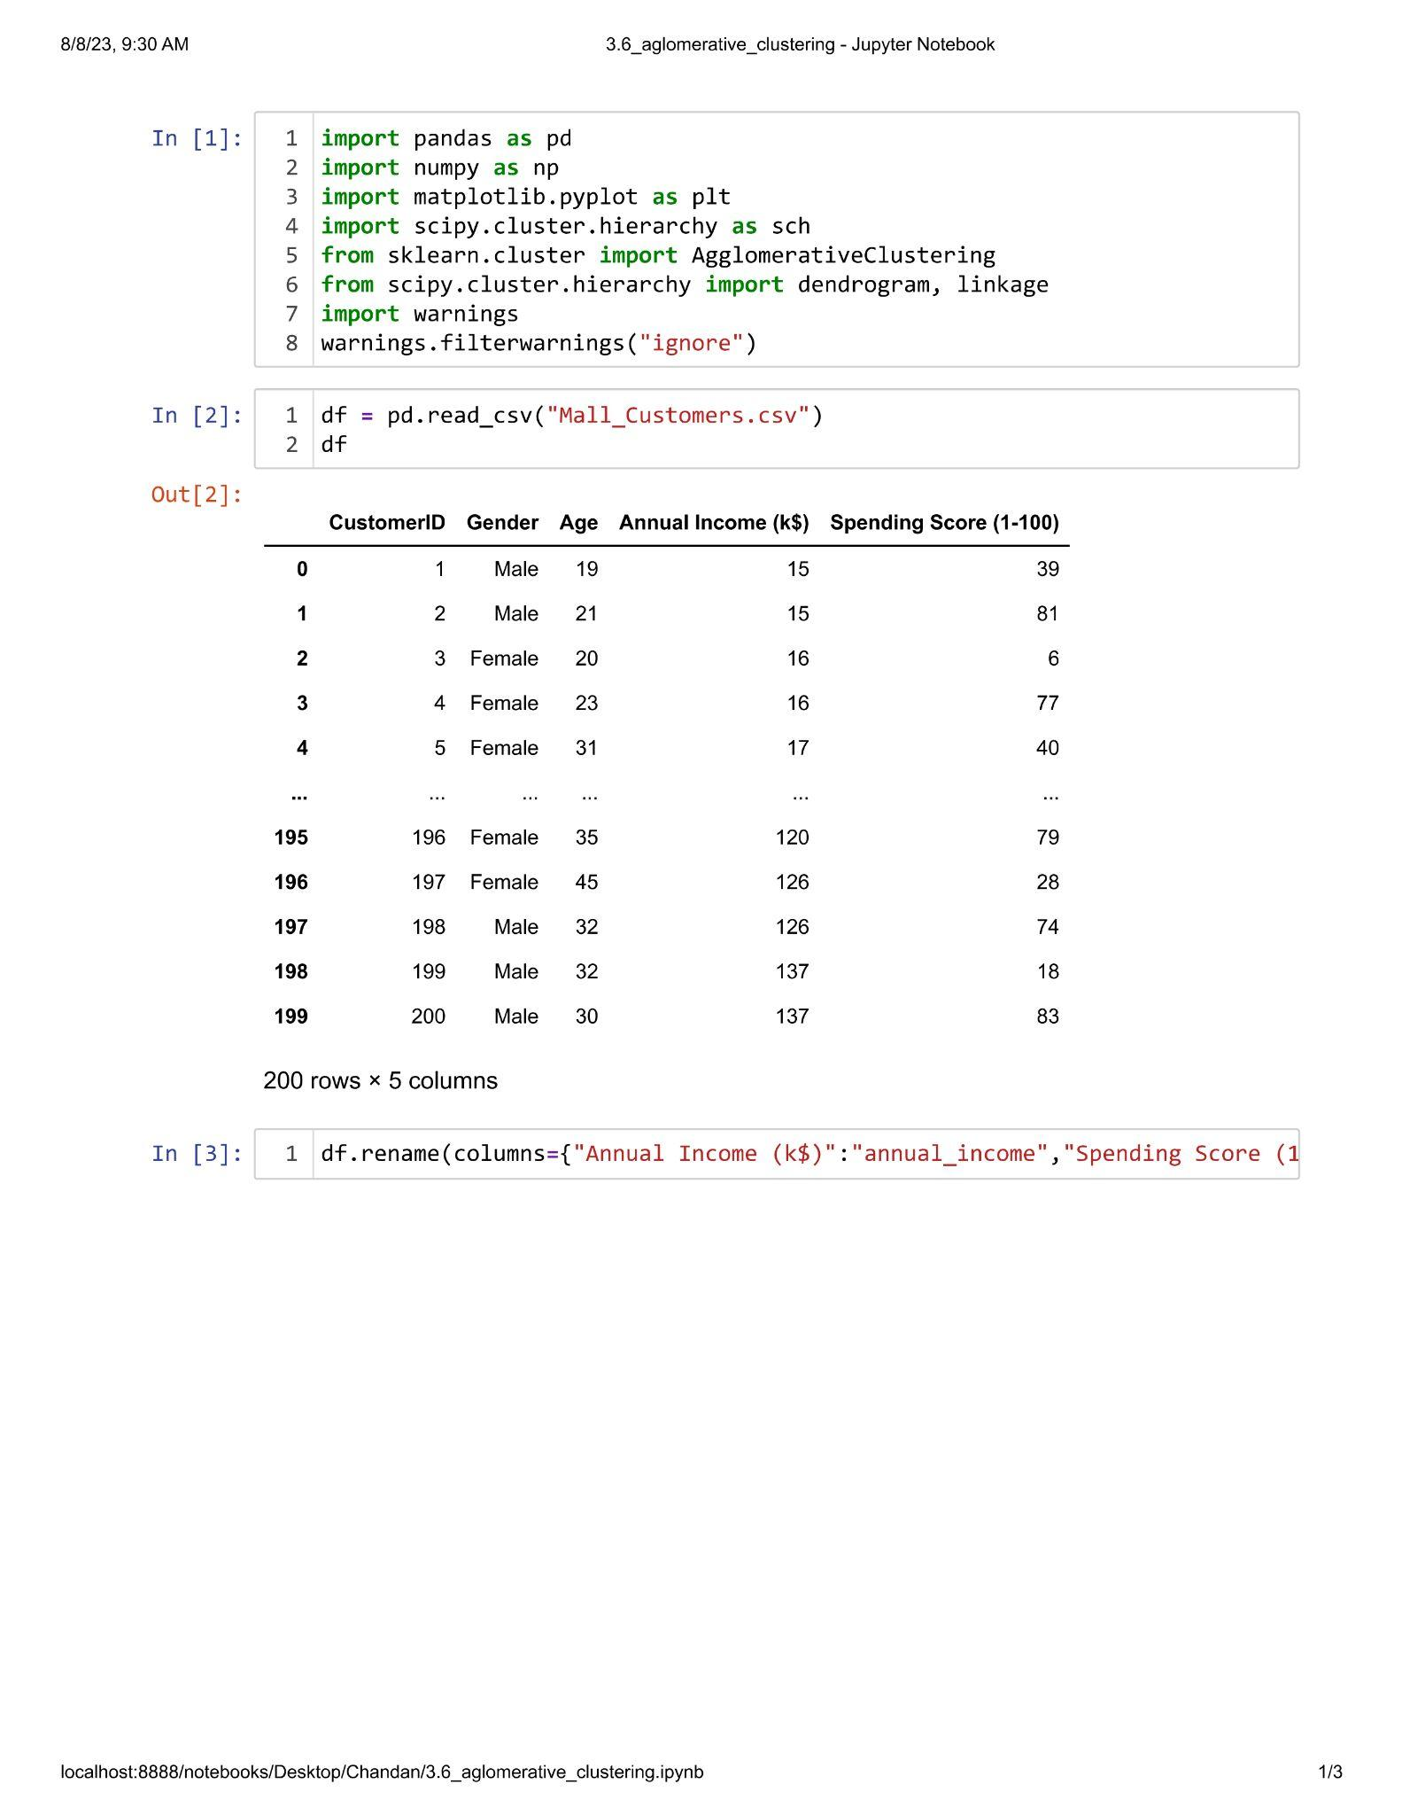

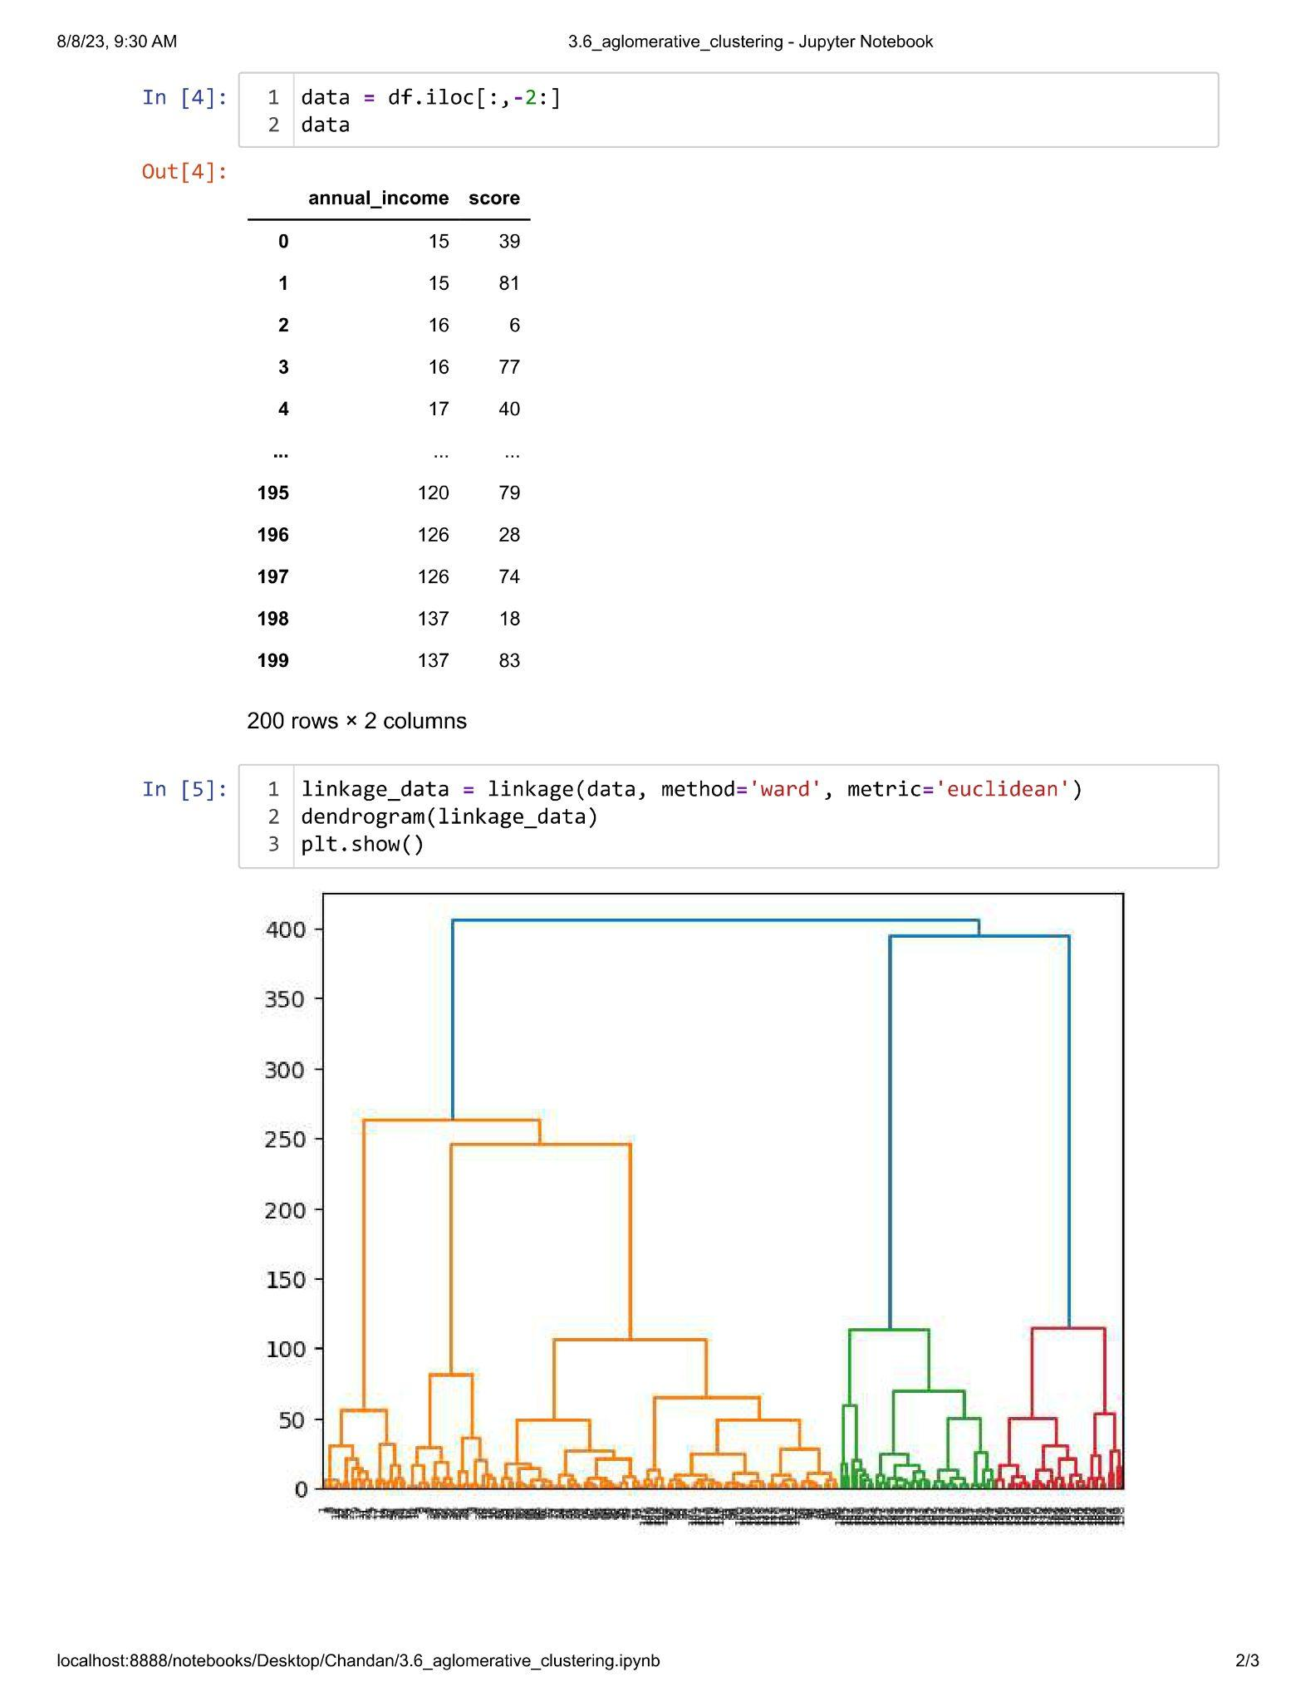

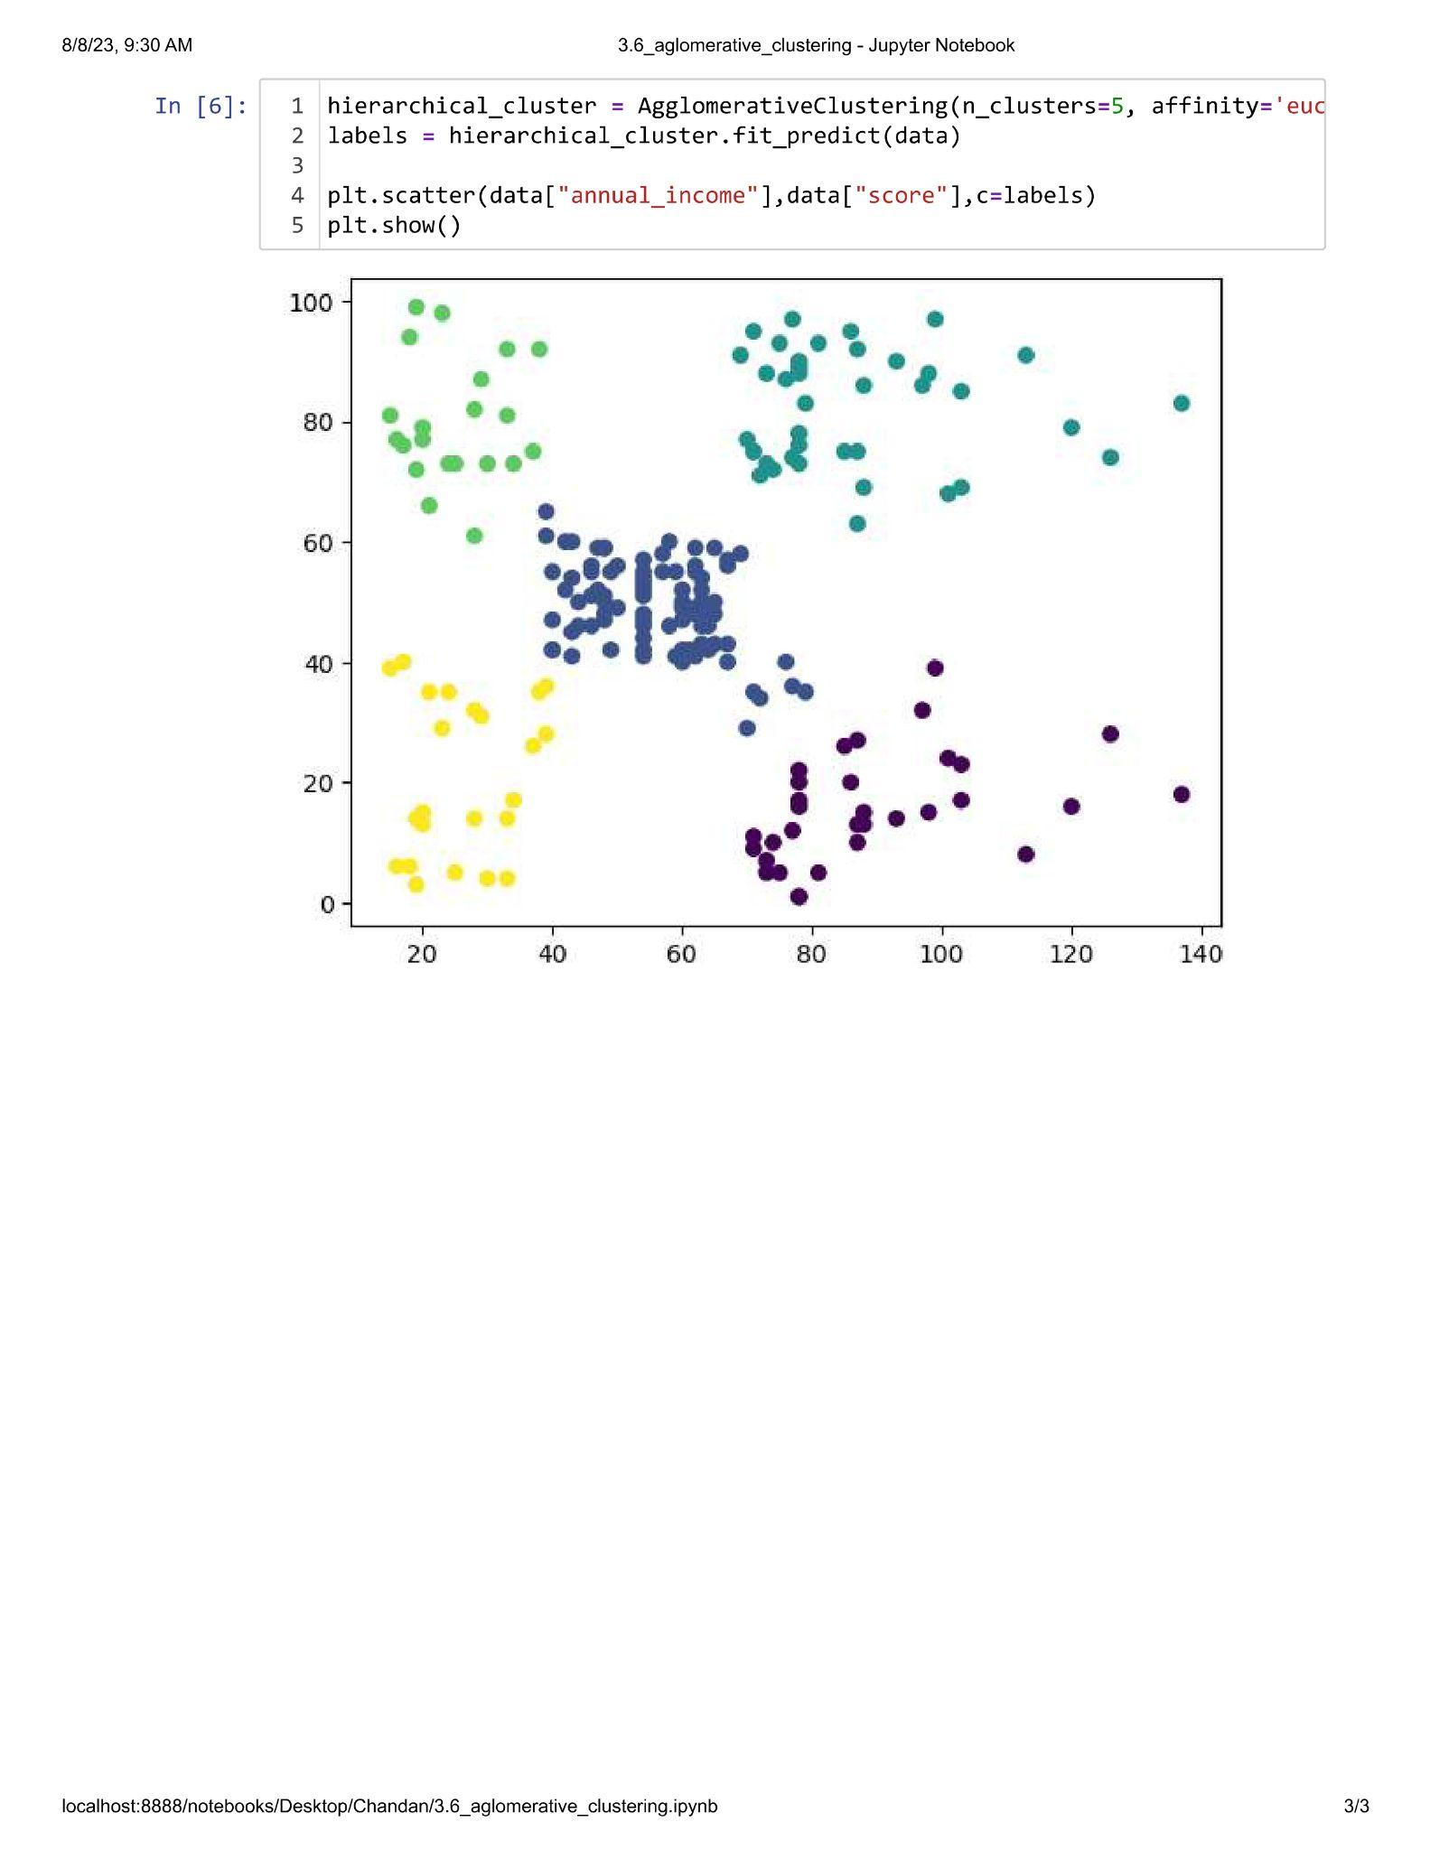

**Practical 3.7**

**Aim : Implementation of Density Based Clustering.**

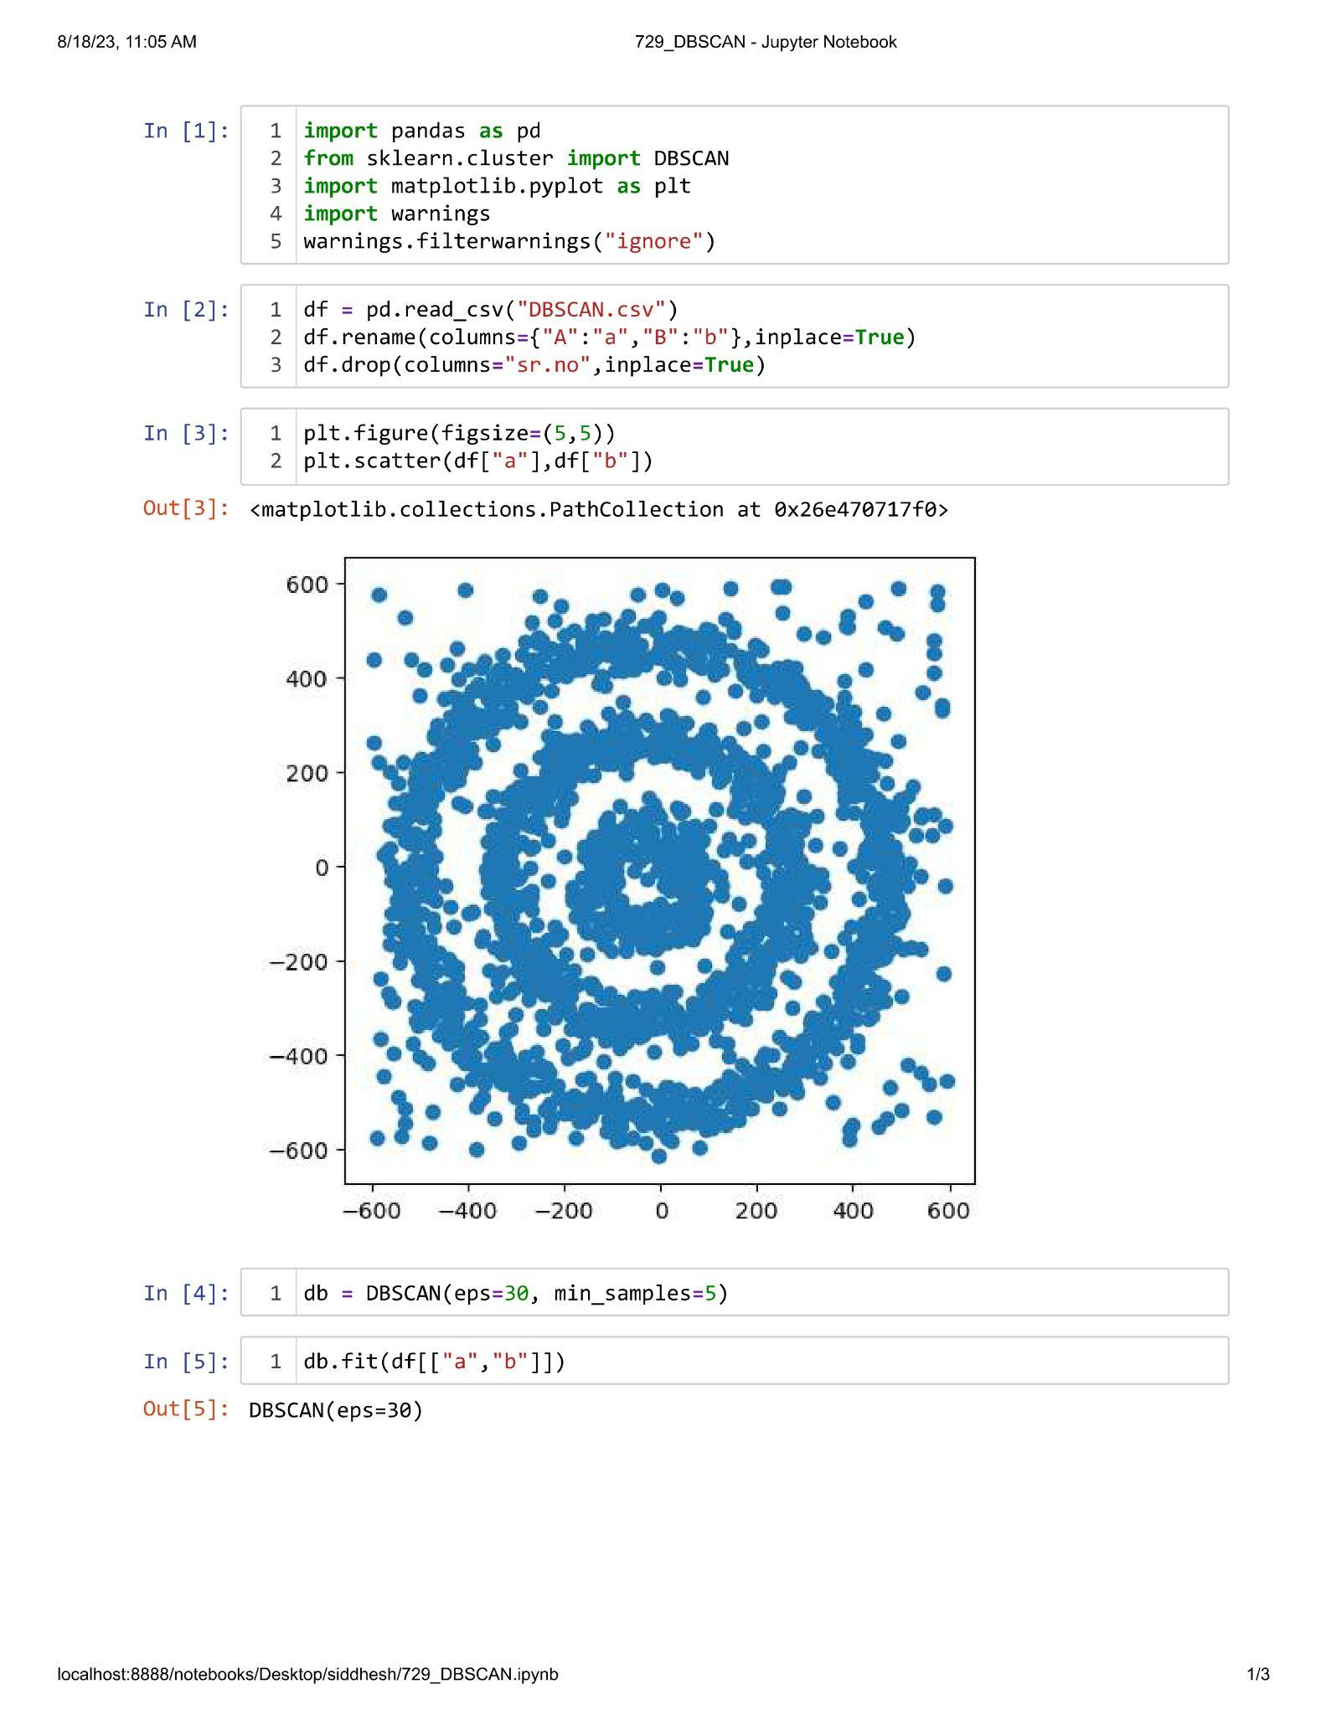

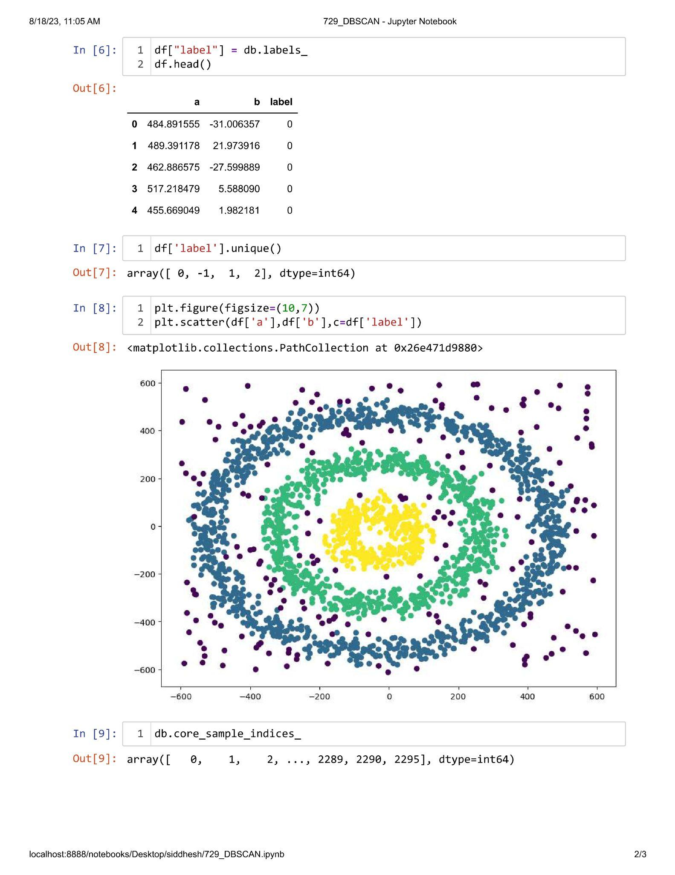

**Unit IV**

**Practical 4.1**

**Aim : Perform Market Basket Analysis using apriori algorithm.**

